|  |
| --- |
| DSC_0077 |
| Major Development Project Automated Visual Lighting System  Design & Technology – Light++ |
| |  |  |  | | --- | --- | --- | | 25313399 |  | 2014 HSC | |

# 

# Contents

[Project Proposal 2](#_Toc396345109)

[Identification and exploration of the need 2](#_Toc396345110)

[Design Proposal 5](#_Toc396345111)

[Preliminary Research 6](#_Toc396345112)

[Factors affecting design 8](#_Toc396345113)

[Analysis of Research 11](#_Toc396345114)

[Justification of Need 11](#_Toc396345115)

[MDP Parameters 12](#_Toc396345116)

[Design Brief 13](#_Toc396345117)

[Project management 15](#_Toc396345118)

[Areas of investigation 15](#_Toc396345119)

[Criteria to evaluate success 21](#_Toc396345120)

[Action, time and finance plans 23](#_Toc396345121)

[Project development and realisation 31](#_Toc396345122)

[Idea Generation 31](#_Toc396345123)

[Exploration of Existing Ideas and Degree of Difference 40](#_Toc396345124)

[Consideration of Design Factors Relevant to the Major Design 43](#_Toc396345125)

[Appropriate Research and Experimentation of Materials, Tools, and Techniques 46](#_Toc396345126)

[Testing of Design Solutions 48](#_Toc396345127)

[Product Display 62](#_Toc396345128)

[Project evaluation 64](#_Toc396345129)

[Ongoing Evaluation 64](#_Toc396345130)

[Analysis and Evaluation of Aesthetic and Functional Aspects of my Design 67](#_Toc396345131)

[Final Evaluation with Respect to the Individual, Society, and the Environment 68](#_Toc396345132)

[Relationship of the Final Product to the Project Proposal 69](#_Toc396345133)

# Project Proposal

## Identification and exploration of the need

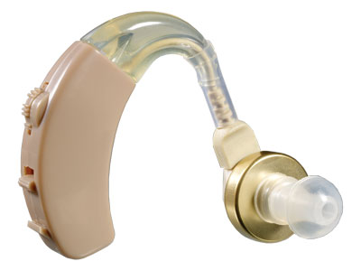As someone who frequently visits my grandmother’s house, I noticed a few things that operate differently and undesirably due to her increasing age and fragility. Some of her senses and functions that are being affected are hearing and memory, for example a door bell or a fire alarm audible alert not being heard, or forgetting to take medications. This is an inevitable outcome in the environment of most elderly people, especially with rates of hearing impairment at 5.7% for the population as a whole, and for the elderly at 30.4%. (As sourced from the Australian Bureau of Statistics.)

Many times have I been at my grandmother’s house when an audible doorbell or medicine alarm has gone off and she has not noticed at all. This greatly bothered me, and after discussing the possible consequences with my grandmother it greatly bothered her as well. Consequently, I decided to setup a mini test to see how a different type of alert would help my grandmother overcome her loss and hearing impairment. The test was conducted informally where I told her that if the lights go very dim, full brightness, very dim, then back to full brightness there would be someone at the door, but if the light dimmed once and went back to normal brightness that it was time for her to take her medication. I visited her house randomly over the next 3 days, acting normally as she was possibly waiting for me to give this visual alert, but for the first 2 days I did nothing. It was on the third day that I tested our alert by signifying the doorbell using the light dimmer, and immediately my Grandmother smiled and opened the door.

Figure 1: A common solution to my grandmother’s problem – a hearing aid

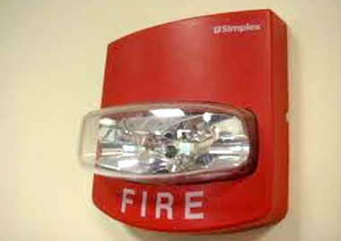Figure 2: A solution to the audible fire alarm problem – An existing, yet aesthetically displeasing solution

My Grandmother was very pleased with this idea of a visual alert over an audible alert and was happy to supply me with another idea for it, and that was to possibly have a visual alert for the fire alarm. I later setup various interviews with my grandparent’s friends who my grandmother thought had a hearing impairment. I asked them a few simple question to really see if there was a need for my product:

|  |  |  |  |  |
| --- | --- | --- | --- | --- |
| Question Number | Question | Reason for Question | Yes | No |
| 1 | Are you hearing impaired in any way? | To see if the participant is part of my target market | 10 | 0 |
| 2 | Do you ever find that you have missed someone at the door due to not hearing the doorbell? | To see to what extent their impairment is, and again, whether they are part of this target market. | 8 | 2 |
| 3 | Do you ever find you forget about your medication and/or not hear an alert for when to take them? | To see to what extent their impairment is, and again, whether they are part of this target market. | 9 | 1 |
| 4 | Would you be interested in a visual alert for these audible alerts you are missing? | To see if there is interest for my product in this market. | 8 | 2 |

5. “How much would you be willing to be prepared to pay?” Based on the qualitative answers I received, I concluded that a good price would be about $1000 for the entire solution.

6. “How would you like to see this visual alert?” to the 8 who answered yes to Q4. Out of 8 people, 2 gave answer that stimulated my thinking on product development direction:

“I would like to have my lights change colour. Say, green for the doorbell and red for the fire alarm. I just don’t want anything too flashy though due to my epilepsy”

“I think if the light were to dim in a pattern when the doorbell rang that would be great. Even if they are off, if they could come on full then dim back down I think I could know if someone was at the door”

EVALUATION: In retrospect, it would have been more accurate and given me more information if I interviewed more people.

Following research I identified a type of product that could solve this issue which is a lighting system that can take external events as commands to change the colour and brightness of a red, green, blue, and white light. Because this solution requires a base system to be built it would be possible to add additional features at potentially marginal cost. Consequently I decided to conduct another interview with the target market.

I politely apologised for bothering the interviewees again, but they seemed happy someone was developing such a product.

7. “As I am building a system that allows an external activity to change the brightness and colours of the lights, what activities would you like to see affect them?” Out of the 10 interviews I conducted, I received 3 answers that seemed like good ideas:

“I think it would be nice if we could have a way to turn these lights off using a remote, instead of having to get up to turn the light off. Lately I have struggled to do this as my muscles are starting to ache.

“Could I automatically have my lights turn off at a certain time because I am worried about electricity costs.”

“Sometimes when I am reading the light colour is too ‘cold’ and bright. I have been looking at a warm coloured reading lamp for a while, but I don’t like reading in the same spot as a lamp is stationary. Could there be a button I could press to enter a ‘reading mode’?”

This interview proved to be of great assistance to me, and the qualitative answers to question 7 really guided the direction of my product.

|  |  |
| --- | --- |
| **Need Analysis –From my initial investigations** | |
| What type of need has been identified? | A product that provides visual alerts for those who cannot hear audible alerts. |
| Who is my target market? | My current target market is those with hearing impairment and memory issues. |
| What do they want my product to do? | They want my product to be a cheap solution to allow them to visually see alerts that would normally be only audibly noticed. |
| How do existing products fall short of providing for this need? | Existing products such as hearing aids are often not worn all the time for example when showering. |
| What demographic features identify this group? | The main demographic is the elderly who have hearing impairments, but this could extend to anyone who has a hearing impairment or even someone who prefers a visual alert over an audible one. |
| What could I do to expand my target market? | I could expand my target market by adding extra features onto this visual alert system such as automated switching off of lights and appliances. |
| Can I produce a product which is both desirable to the target market and economically viable? | Potential yes, as I am aware that there is technology that can deliver the required functionality and that the cost of components are relatively affordable. |

## Design Proposal

My design proposes to give the elderly in particularly those that are hearing impaired a better quality of life, by meeting the following crucial needs of that demographic.

### Missing alerts due to being hearing impaired

Many elderly people struggle to hear audible alerts due to being hearing impaired. I propose to fix this primary issue by allowing a visual stimulus to be activated whenever an audible one normally would. This will not attempt to replace hearing aids, but instead is attempting to provide an easier all round solution that the elderly can rely on no matter what situation they are in.

THE NEED: This is my primary need, and the main need my product will be designed to fulfill

### Struggling to turn off lights due to aches and pains

Elderly people sometimes struggle with turning off lights, and it can become a huge chore that taxes their bodies every time with pain. I propose a simpler way for these lights to be controlled. This proposal is secondary and will leverage off the primary proposal of creating visual alerts.

### Concerned about high costing electricity bills each month

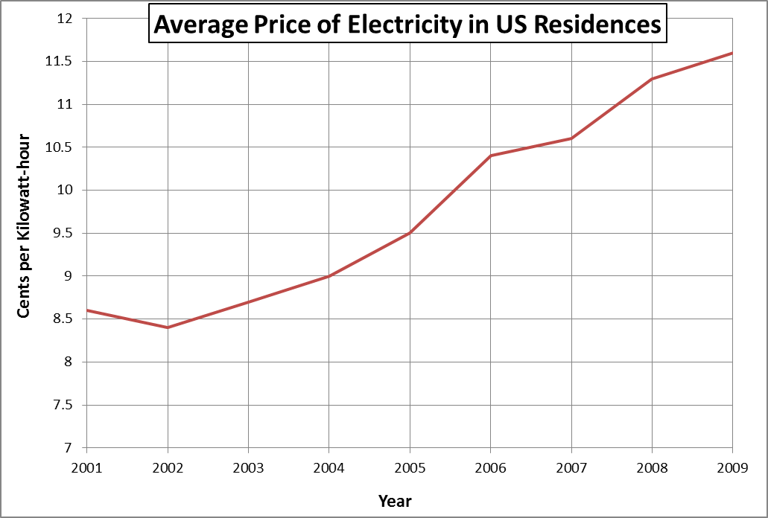

With the price of electricity rising much faster than inflation, people need to start taking steps to reduce their energy consumption. I propose a system that uses a lot less electricity by combining two features. The first feature is using low power consumption electronic parts, such as LEDs that can greatly reduce consumption by up to 50%. If I combine this with the second feature of lights that automatically turn off after a set time, I think I could reduce electricity used in lights significantly.

### Light is too bright for comfort

A standard ceiling globe is not very customisable, and may provide discomfort for some. I propose a system that allows the customer to control the brightness and colour of their lighting to suit their own personal needs.

### Summary

These four design proposals are crucial for me to meet if I want my product to be a success. The first proposal is my primary requirement and an entire automation system needs to be built to complete it. However because this base automation system will be already built I can easily leverage out into the three other secondary proposals at minimal additional cost. This will improve the chance of the product being successful.

## Preliminary Research

I will complete preliminary research on all of the needs, to ensure they are genuine needs that cannot be satisfied by existing products.

### Missing alerts due to being hearing impaired

In 1993 (most recent survey), the Australian Bureau of Statistics compiled the number of those with a disability, which was 18.1% of the population. Of this number, 31.5% had a hearing impairment. This equates to 5.7% of Australia’s population having a hearing disability. This large demographic confirms the need for a visual stimulus rather than an auditory stimulus to be produced when an alert is activated. Although there are already a few products which cater to these needs:

**Hearing Aids** - Are the most accepted form of correcting a hearing impairment, and is a good solution to this target markets need. It does lack some main features though, such as its price and its need to be worn 24/7 which can be uncomfortable.

**Visual Fire Alarm** – Is a good form of a visual alert. These are placed in crowded and noisy places but look very un-aesthetic, and are very hard to install and setup.

**Front Door Cameras** – My grandmother purchased one of these systems for $400 and hoped it would fix her problem of missing when people were at the door. Unfortunately the product did not fulfil the need, as the systems main alert was an audible alert, with a secondary alert of the screen flashing with a calling symbol. My grandmother soon returned this product.

EVALUATION: Analysing these products allowed me to better conceptualise the kind of solution I needed to design.

To conclude, it is evident that a genuine need exists that has not yet been completely fulfilled.

### Struggling to turn off lights due to aches and pains

This is a very subjective topic, due to the fact that some people may just be lazy instead of having aches and pains. Regardless, there is still a genuine need for being able to turn off a light without getting up to go to the power point. Some hard facts for this need can be seen in the statistics of wheel chair bound individuals, which is as high as 2.9% in the elderly demographic. In general, 17.4% of the elderly demographic need an assisting walking device to travel by foot (as sourced from <http://dsc.ucsf.edu/>). This shows that there is indeed a genuine need outside of lazy individuals who need this product.

### Concerned about high costing electricity bills each month

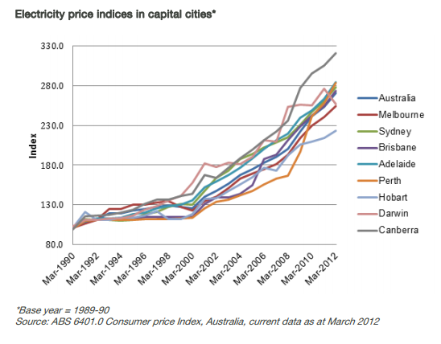Preliminary research does not need to be done on this to know that there is a need for saving electricity, hence saving money and the environment. Although, it is vital to be researched as the rate increases at an exponential rate as shown in the graph sourced from <http://www.esaa.com.au/> (The Energy Supply Association of Australia).

If this rate continues, by 2020 the electricity price indicia for Australia will be around 350. This shows a genuine future need my product will be able to target. This is good as a successful product needs timing to be successful, and my product should be realised just before the curves gradient becomes more rise over run.

### Light is too bright for comfort

This may not seem like a genuine need, but there is science behind different coloured lights and how they affect cognition. “Exposure to the light of white LED bulbs, it turns out, suppresses melatonin 5 times more than exposure to the light of high pressure sodium bulbs that give off an orange-yellow light.” - <http://www.sciencedaily.com/>. This study released by science daily shows that white light reduces melatonin in the body, which is a vital hormone for sleep and relaxation. The study also shows that orange-yellow light is the best for melatonin production.

This is a genuine need as some people notice this uncomfortable feeling they get from ‘cold’ white lights.

## Factors affecting design

With the proposed introduction of my product automating the visual lighting in a house, many aspects that implicate the design process arise such as ecological, economic, social, ethical, and legal factors. Any problems or issues identified after considering the implicating factors need to be designed out of my proposed product where possible so as to optimise the uptake and success of the product.

### Ecological

Ecology is relating to or concerned with the relation of living organisms to one another and to their physical surroundings. This fits in with automating the visual lighting in a house in terms of the pollution the product gives off, and the cradle to cradle life cycle of the product.

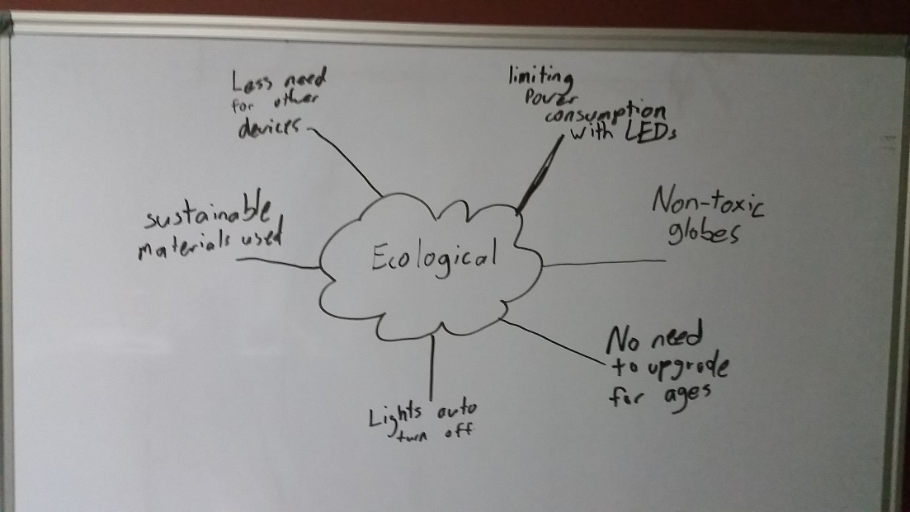One of the main advantages of automating the visual lighting in a house is the aspect of saving the environment through the limiting of electricity usage. Automating the visual lighting in a house can strive to achieve this goal by having timers behind the ceiling lights which automatically turn them off after a certain period of time, or a certain period of time when not in use. Another aspect of ecology is the cradle to cradle life cycle of the product. LEDs have a good cradle to cradle cycle so I should definitely consider using them in my design.

### Economical

Economics in relation to automating lights is the amount of money that will be spent, saved, or lost when using this automation.

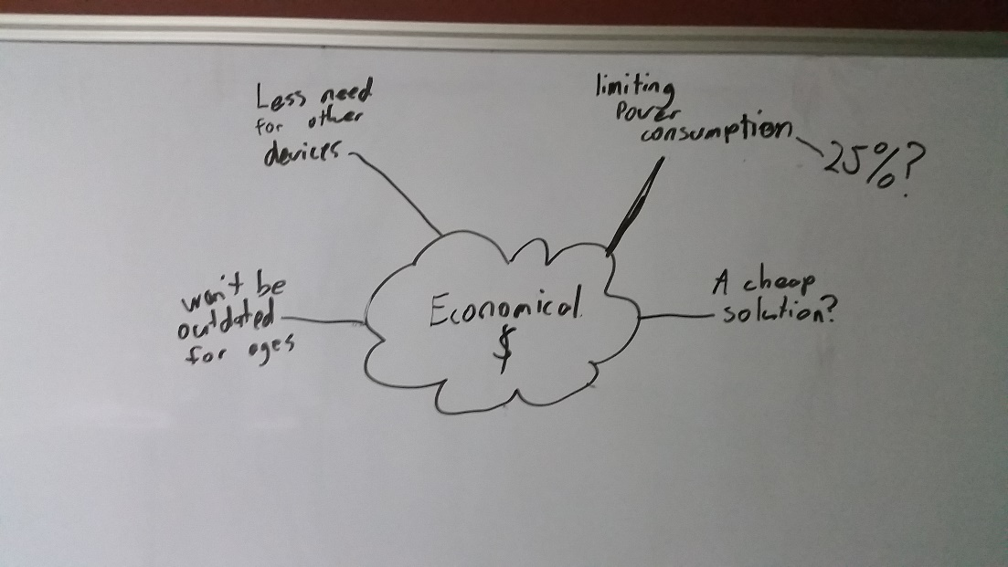A common aspect of ceiling lights is the consideration of the amount of money that can potentially be saved through the use of new and existing technologies. A technology I could use here could be using automation to turn off the lights when not in use, as discussed in ecological factors. Another factor to consider when calculating the electricity saved by automatically turning off appliances is the electricity needed to run this automatic system.

When calculating the savings made with a home automation system, it is not as simple as looking at your electricity bill and observing the lower number. It is a more complex formula that must involve the price of the product, the price of installation, time until obsolescence, and maintenance.

Implications may occur when using this product, so it is essential that upfront costs and maintenance are factored into the calculation of the economic benefit of the system. For instance, a family’s electricity bill may be reduced by $500 a year by using light automation. However, if the system costs $1000 to buy and install it will take 2 years for the system to pay for itself, and if the system costs money to maintain, the payback period would be even longer. In some cases the payback period may be too long to justify the system or the annual savings may not be enough to cover maintenance costs.

Before installing the system, an objective cost benefit analysis should be carried out.

### Social

A social positive of this system is that it may become a topic of conversation by the elderly, much like computers have. This is free publicity and advertising, and will provide a huge boost to the way my product is viewed. Some negatives do occur though, such as individuals misusing this system to be lazy, but that is up to the individual to decide.

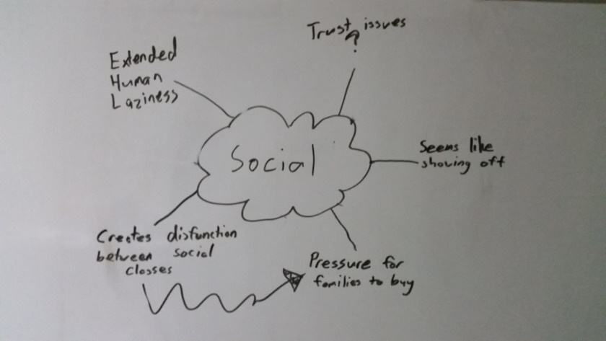One of my main concerns with such a product is that it may become expensive to purchase due to the technologies that may be used. If the product does become a success and is widely talked about in the elderly demographic, pressure may be placed on the individual to purchase my product to socially fit in. This is bad as not everyone can spare $1000 for a new lighting system, and may put pressure on the individual to not buy as much necessities, such as food, whilst they are saving for this product.

### Ethical

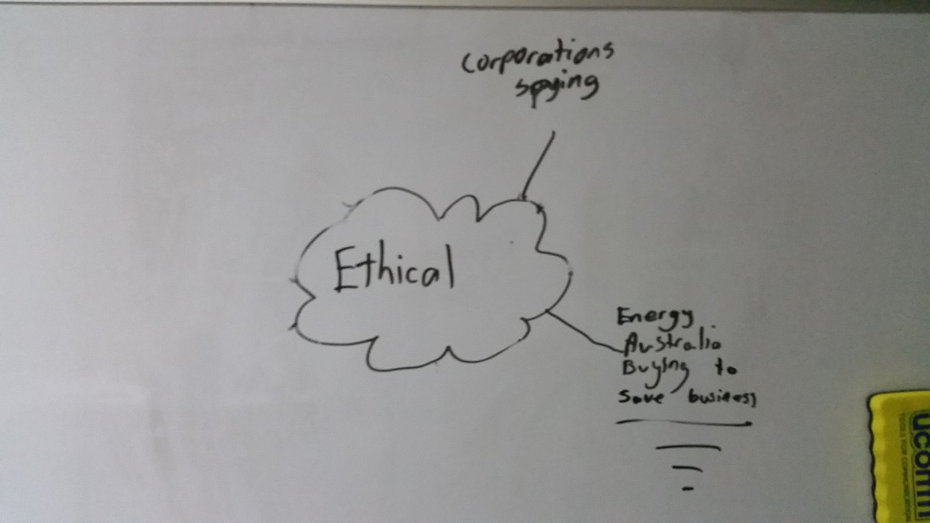Ethical behaviour can be simply defined as not taking unfair advantage of someone or something. Such ethical implication that may arise from automation of ceiling lights is data can be collected from the user unknowingly and sold to companies for money.

I should make sure that this automation system does not collect information about the user or allow an external (internet) entity to access the system without authentication.

### Legal

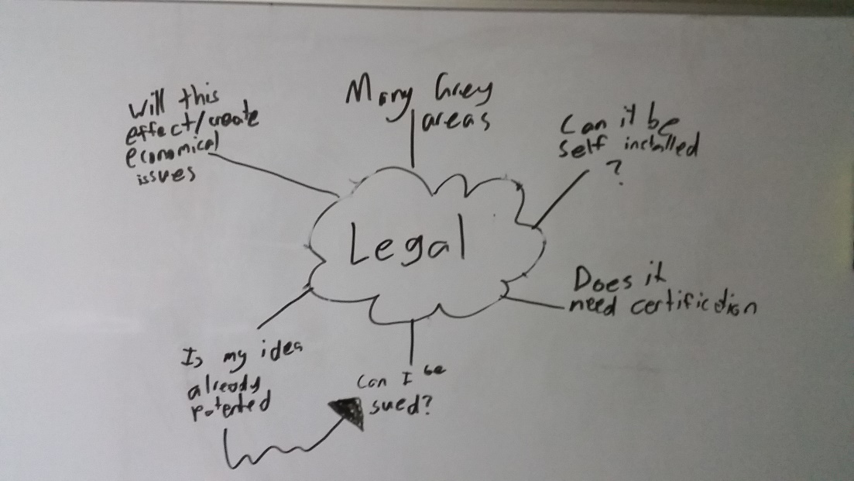Legal can simply be defined as the rules and regulations that govern how things should occur. As light automation is a relatively new concept, there are still grey areas for what is legal and illegal. From these grey areas, implications can arise, such as whether or not they can be self-installed. It is vital I do more research on this factor when I have a better idea what my product will be.

EVALUATION: Mind-mapping on a whiteboard really helped me set out my ideas. I was lucky to have access to a whiteboard at my desk, which acted as a very fast changing place to take notes and plan diagrams.

## Analysis of Research

My preliminary research has shown me what I can expect when designing this product. With the research comes some negative points in regards to what I would like to do, especially implicated in my legal research. Although, there are still many positives that I can hope to achieve such as the ecological and economic benefits that I explored.

|  |  |
| --- | --- |
| Factor | Key Point |
| Ecological | * Reduction of electricity consumption which is good for the environment |
| Economical | * Reduction of electricity bill due to automation |
| Social | * Could become a success through the elderly talking about this ‘new technology’ * May put stress on an individual who cannot afford the product |
| Ethical | * Be careful to not allow anyone other than the user access to the systems information |
| Legal | * The laws are not clear what is legal and illegal, which may affect installation |

## Justification of Need

After establishing that there is indeed a market for this product, I have to evaluate my findings and ask myself why I am doing this product. A good criteria to evaluate the justification of a need is to have a rational scenario, mimicking scenario, regulations scenario, and a standards scenario.

### Rational Scenario

This is the action of looking at hard facts and numbers to see if they need can be justified through logic. It is obvious through my preliminary research that there is a large demographic, i.e. hearing impaired elderly people, that require visual rather than audible alerts, therefore there is a genuine need to develop a solution to their requirement.

### Mimicking Scenario

This is more colloquially known as the “if they did it, we can do it” scenario. The mimicking scenario is the research of other products on the market and looking at how they became a success, and drawing inspiration from that. In my research I have thoroughly gone through the design process and marketing process of the Domus - RGB LED Down light Flare. From this product I have drawn inspiration from such features as the aesthetic ‘satin white aluminium frame’ and the functional wireless communication method. Although the mimicking scenario is a good method to success, if you mimic a product too much, your own product might look like knockoff or not become successful as the exact same product is already out there on the market.

### Regulation Scenario

In this scenario you look closely at the rules and regulations in place that you must work with to create your product. An initial need I had in mind was for an easy installation of my product by the user. This would allow the average person to buy my product off the shelf and install it themselves with ease when they get home. Unfortunately, due to regulations and laws this need may not be fulfilled by my product, and thus will shape the design process of my product as I may no longer be able to include self-installation as a feature.

### Standards Scenario

While regulations provide an explicit measure to justify change, standards expectations provide implicit reasons for change. When you use the standards scenario to justify your agenda, you are not proposing that the product needs something as much as you are suggesting that if the product doesn’t need that something, it will be of a disadvantage. After considering this scenario, I intend to use a mobile phone as a controller for my product, because I believe it will become a standard for home control in the future.

## MDP Parameters

When creating my MDP there will be many parameters I must abide to. Many of these parameters would not be as strict if this project was created professionally, but since I am a Year 12 student the parameters are very limited. Some parameters to consider are time, skills, finance, resources, and personal limitations.

### Time

Time is a major consideration when designing the product as you cannot go over the deadline, nor do you want to finish with too much time spare. Finishing over the deadline will result in a penalty to the success of the product. In this case the penalty is major and result in a complete failure of the product. If I finish with too much time to spare, than my product may not be the best it can possibly be.  
In total, I have about 200 days to complete this product and must be careful I stick to a time plan.

### Skills

This parameter can be split into two different categories pre-learned skills, and intra-learned skills.

#### Pre-learned Skills

Pre-learned skills are skills that I already have acquired. I should try and focus on a product that I already have some pre-learned skills. Such skills may be my knowledge in programming, fitness, electronics, and emerging technology.

#### Intra-learned skills

Intra-learned skills are skills that need to be learnt in order to complete a stage of development in either the planning process or design process. For this project I will need to learn many skills to a high proficiency level. As I don’t quite know what my final product will be, the learning process of these skills will be documented later in this portfolio. I also need to be careful of my mental parameter and not take on a workload that is too great to be completed in the set amount of time.

### Finance

This parameter can be split up into four different sub parameters; research and production cost, cost of the final product, resources, and personal limitations.

#### Research and Production Cost

This is the total budget for the purchasing of different materials and resources to create my product. Usually, creating a product is a very expensive process and cannot be done without a money incentive kick-start. As I am only in Year 12 with no income, I do not have much money to spend on various resources and materials for the design, so I am planning on setting up a spreadsheet that documents all of my purchases. My mum and dad have both granted me $350 to spend freely on this product, so this will be my maximum budget. Thankfully many resources I would normally have to pay for are free to me through my schools own workshop rooms which offer lots of equipment, I also have the resource of being able to talk to knowledgeable individuals in the field through the Technology Staff at my school. With these two free resources, I think $350 should be enough to complete the research and production of a few of my products.

#### Cost of the Final Product

Through my preliminary research there are competing products that do similar things to mine. I have not at this stage of the project completed in-depth research on these products but a main flag stood out to me on each, their price. Most of these products are averaging roughly $100 per bulb, even without the main computer system, which either does not exist or goes upwards of $1000. This is unaffordable particularly for the elderly and is one of the main aspects keeping these types of products from reaching commercial success. I propose my final product to cost around $25 per light, and $100 for the computer system to better suit the gap in the market.

#### Resources

At home I have very little resources I can use, besides a soldering iron. Thankfully, I have access to the schools equipment that I can use almost every day for no cost.

#### Personal Limitations

I need to be aware of my financial limitations and that the money I have is not infinite. I should create a finance plan to calculate how much this project will cost me, updating it and evaluating it every time something is purchased and every time I am thinking of purchasing an item. I also will attempt to control the costs through making sure the scope of what I intend to do is limited and controlled. Fortunately, the grant from my parents is not a number set in stone, and I am sure if I need another $50 I could politely ask my parents and it may be granted. I will also attempt to borrow items off people I know when I can. This gives me a very fortunate situation in that I have a reasonable contingency if things do not go according to my plan.

## Design Brief

Based on my preliminary research and identification of the target market and its need, I would need to:

* Build a system that delivers a visual alert in place of an audible alert
* Keep costs less than $1000 for final product
* Design especially for the elderly demographic
* Keep research and development costs less than $350
* Reduce the struggle to turn off lights due to aches and pains
* Reduce high costing electricity bills each month
* Allow the light brightness to be customised by the user

Through a brainstorm process, I was able to list three different possible solutions to the design brief, and also explored briefly why an existing product was not the best solution to the design brief.

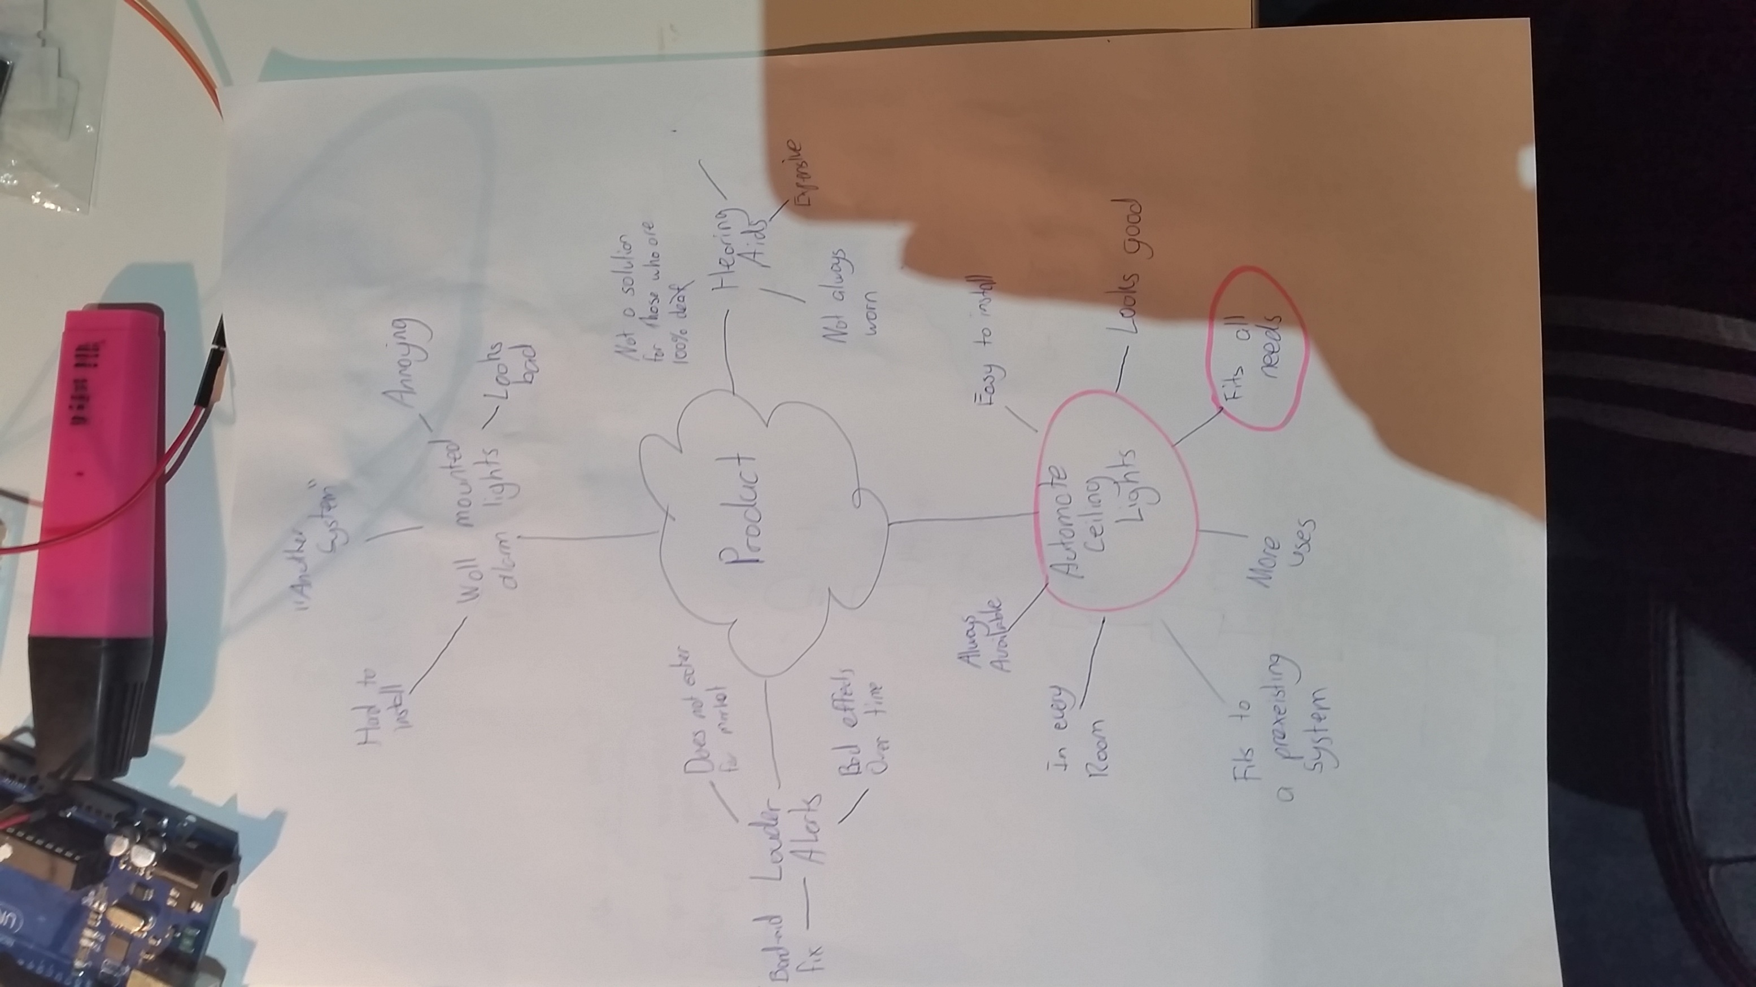

By evaluating the design brief, I have decided the best solution would be to base my solution on an automated light system. An automated light system is usually based on an interactive way to control a houses lights. This would provide a platform for me to implement a way to trigger visual alerts through a customised computer program, which I will need to develop.

I also must come up for a name for my product, and was considering Light++. This is a play on programming syntax, where an object followed by “++” means that it is the object plus 1. Therefore my product name means “better than a light”.

# Project management

## Areas of investigation

### Skills

It is important that I set out to investigate any potential skills required and any gaps in skill proficiency levels.

1: A key to the Area of Investigation table

|  |  |
| --- | --- |
| 1 | Fundamental Awareness (basic knowledge) |
| 2 | Novice (limited experience) |
| 3 | Intermediate (practical application) |
| 4 | Advanced (applied theory) |
| 5 | Expert (recognized authority) |

| Skill | Proficiency Level | Where I learnt it | Where I am possibly going to use it | Needed proficiency Level | How I can close the proficiency gap |
| --- | --- | --- | --- | --- | --- |
| Soldering | Advanced | Self-taught at home through a hobby for repairing old circuits. | I will be using this skill throughout my project to solder components together | Intermediate | N/A |
| Programming C | Fundamental Awareness | Reading other peoples code | To program the behaviour of integrated circuits such as the common ‘Arduino’ chip the Atmega328PU | Intermediate | I am planning on reading the book “Learn C The Hard Way” which will teach me how to code C through a blunt learning style which I find suits my learning needs. |
| Programming Python | Intermediate | Self-taught through the Board of Studies Software Design and development course | To program the main control system that will dispense commands to the light systems | Advanced | I plan to read “Learn Python The Hard Way” for the same reasons as above. I think it will be easy adapting to the same author teaching the two languages |
| Circuit Building | Novice | Through YouTube tutorials | To build the senders and receivers of the lights | Intermediate | I have read through some tutorials on <http://www.ladyada.net/learn/arduino/> and enjoy the teaching style, so I will continue learning from there. |
| Network Infrastructures | Advanced | Year 10 work experience, and ongoing applied theory for own homes infrastructure | To allow the user to interface with the lights | Novice | N/A |

### Materials

Just as it was important to investigate my skills, it is just as important to investigate the materials I will need to use.

2: A key to the Area of Investigation materials table and the Area of Investigation resources table

|  |  |  |  |
| --- | --- | --- | --- |
| Key | Type of Research | Conduction of research | Level of information output |
| 1 | Descriptive | * Focus Groups * Interviews | High |
| 2 | Historical | * Investigation of historical events | Medium |
| 3 | Experimental | * Developing Prototypes * Sample Testing | Very High |
| 4 | Operational | * Assessing pre-existing products * Testing of pre-existing products * Visiting Sites * Product Testing | Medium |

| Areas to Investigate | Specific Areas of Investigation | Type of Investigation (see key) | How I will conduct this investigation | Justifications or reason |
| --- | --- | --- | --- | --- |
| Electricity use of an LED | * Electricity usage of an LED * Electricity usage of a standard globe | Experimental | I will set up two circuits that consist just of a power supply and the light source in question. I will measure the voltage and ampere that the light uses, and convert it to watts to test what uses the most electricity | I am investigating this to make sure that LEDs can be used as a synonymous substitute to traditional ceiling globes. If LEDs use around the same electricity or less electricity than traditional standard globes, I will continue my project using LEDs. |
| Brightness of an LED | * Luminosity of LED * Luminosity preferred by public | Experimental | I have purchased a light sensor from Jaycar that gives a reading of the brightness received, varying from 0 for no brightness to 1024 for maximum brightness | I am investigating this to make sure that LEDs can be used as a synonymous substitute to traditional ceiling globes. If the LEDs are brighter than or just as bright as traditional ceiling globes, I will continue to use LEDs for my project. |
| Cheapness and quality of variable wireless communication methods | * Range the communication method can send data * Cost of the communication method * Accuracy of the data sent and received | Operational | I will conduct this investigation by exploring the different aspects of each method such as the price, sending range, accuracy of the data, and speed the data is sent at. This will be documented later in my folio. | I am investigating this to ensure that the method I use to send data is accurate and can be sent at a long range of 30m for a cheap price. When I investigate each communication method, I will pick the method that gave the best results and will use it in my product |
| Ethernet Device to use | * Speed it can process at * Latency when left Idle * Accuracy the data is received at | Operational and Experimental | I will conduct this investigation by using my knowledge on network infrastructures. I will set up three different tests, one for each area of investigation for the Ethernet devices. | I am investigating this to make sure I am using the best Ethernet device. If the Ethernet device is not chosen correctly, the ramifications will be obvious and can cost the success of the product |

### How to Correctly Use Resources/Tools

| Areas to Investigate | Areas of Investigation | Type of Investigation (see key) | How I will conduct this investigation | Justifications or reason |
| --- | --- | --- | --- | --- |
| How to correctly cut a piece of wood safely | * What the best machine is for cutting large pieces of wood accurately and safely | Historical | I will consult the members of the wood working faculty at my school. This should be an easy investigation as these people have done this before in the past many times. | I never learnt proper woodworking skills, so I will need to learn now. This is a handy resource to have in the future. |
| How to correctly use a Multimeter | * How to measure voltage * How to measure amps | Experimental and Descriptive | I will ask my Design and Technology teacher how to use a Multimeter correctly. I will then go and test it on a custom circuit | Knowing how to use a Multimeter is a huge benefit when testing and designing circuits, as it allows the knowledge of what the voltage and amps are at what part of the circuit. |
| How to solder safely | * Precautions and safety guidelines to using a soldering iron | Descriptive | I will look up YouTube tutorials on how to solder correctly. | I already am a decent solderer, but last year suffered a bad burn to my hand by not following correct safety procedures |
| Correct way to paint wood | * How to correctly paint wood and get a good end result | Descriptive, Experimental | Another Design and Technology student in my class is a very talented painter, I will ask him how to correctly paint. I will then do a few test paints and take them back to him for evaluation and extra tips | Although painting does not play a direct role in my product, I may need to paint a display to look good, reflecting well on my product. |
| Correct way to use glue | * How to use glue to correctly stick pieces of wood together that will last | Descriptive | I will ask my Design and Technology teacher how to correctly glue wood and safety to follow | Last time I used glue I got dizzy from the fumes, this is not safe. Another issue I had last time was that the glue did not hold the wood together well enough. |
| How to etch PCB | * I am not very knowledgeable in this area, and am unsure what areas to investigate yet | Operational or Descriptive if I ask for help | My Design and Technology teacher is experienced in this field and will help me conduct experiments or point me to the correct conclusion form previous experience | I am investigating this as a PCB is vital to include in a commercial product. |
| How to draw schematic on PCB | * Best technique for a good quality ink transfer | Experimental | There are many PCB tutorials on the internet that claim to be using the best method of drawing a PCB, but many people struggle to correctly follow these methods. Usually a PCB can be made in an industrial setting in a few minutes. | As previously stated, it is vital I have a PCB. Because of this, it is important to correctly transfer my design onto the physically PCB copper. |

## Criteria to evaluate success

|  |  |  |  |  |  |  |
| --- | --- | --- | --- | --- | --- | --- |
| Criteria | | Priority | | Explanation | Method of Evaluation | |
| Satisfaction of Design Brief | | | | | | |
| Build a system that delivers a visual alert in place of an audible alert | Very High | | This is the main function of the product. It is what the target market wants | | | Final product testing |
| Keep costs less than $1000 for final product | High | | The target market wants the final product to cost less than $1000 | | | Assessment of final product cost based on knowledge gained during development and construction |
| Design especially for the elderly demographic | Medium | | Because of my previous two criteria’s, I need to make sure this product is being designed for the elderly | | | Get my grandmother and selected friends to operate the system and assess their reaction |
| Keep research and development costs less than $350 | Medium | | As I do not have much money and have been granted $350, I should try to keep within this budget | | | Add up actual costs incurred and compare to see if it is below $350 |
| Reduce the struggle to turn off lights due to aches and pains | Medium | | This is a secondary need for the target market | | | Proven during final product testing if my system can remotely turn off lights |
| Reduce high costing electricity bills each month | Medium | | This is a secondary need for the target market | | | I will evaluate this by seeing how much electricity the final product uses |
| Allow the light brightness to be customised by the user | Medium | | This is a secondary need for the target market | | | This will be proven by testing my final product |

## Action, time and finance plans

### Action Plan

I plan on using this action plan to guide me to complete this project



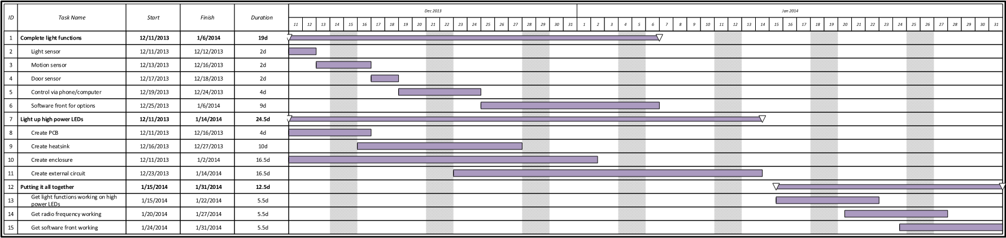

**Time Plan**

I created the original time plan below, but once I commenced my project, I realised that the time plan was unrealistic and did not allow me to complete each task on time. After evaluating the previous time plan, I created another time plan which will be my final one.

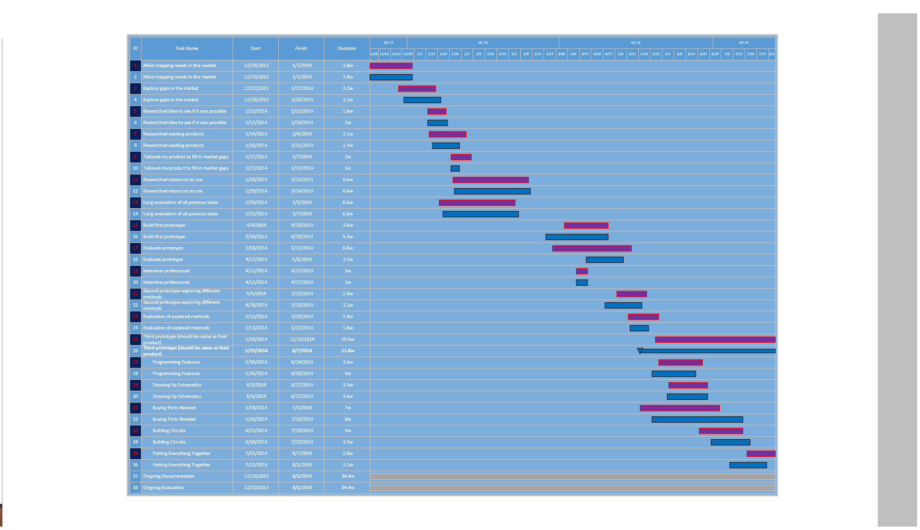

KEY: The purple bars are planned and the blue bars are actual event timing

### Finance Plan

My budget for this project is $350 as previously mentioned, as my parents have kindly contributed this to me. This budget is not set in stone though, as I can always take money from my own bank account. It is still very important I strictly stick to the structure of this finance plan.

| Item | Item Description | Proposed Cost | Actual Cost | Justification of Difference |
| --- | --- | --- | --- | --- |
| Raspberry Pi | The raspberry pi is the brains of the entire project. It is the centre of all communication that occurs in Light ++’s infrastructure. | 50 | 45 | I applied for an education coupon to receive $15 off the Raspberry Pi and was granted it. The raspberry pi was $60. |
| 3 x Arduino Uno | The Arduino Uno’s were initially to prototype each node (light). Since then <> they have changed purpose and now can be considered as part of the final product. Arduino Uno’s contain a microprocessor that I have hooked up to the LEDs. The microprocessor sends out a signal to these LEDs based upon certain events that are happening around them. | 60 | 25 | I purchased the first one for $15, then purchased the second one for $10 as second hand. The third I borrowed off a friend for free. |
| 6 x NRF240I+ | The NRF240I+ radio frequency modules are very reliable for sending small amounts of data over radio frequency waves. They are at every point of Light ++’s infrastructure, including hooked up to the Raspberry Pi (through median of an Arduino), and also connected to each Light ++ node. | 20 | 24 | Initially I purchased 2 of these from eBay for $2 each, they worked fine but took 4 weeks to arrive. The next 4 I wanted fast, so I decided to order from an Australian warehouse called dx.com. They were $5 each and were exactly the same as the eBay ones. |
| 25 x RGB LEDs | These are just simple RGB LEDs with a diameter of 5mm. Their brightness is not good enough to be in the final product, but I am purchasing them for prototyping. | 5 | 4 | N/A |
| 25 x White LEDs | These again are just simple LEDs that emit a white colour. They are not bright enough for the final product, so instead will only be used for prototypes. | 2 | 2 | N/A |
| Various Resistors | Throughout my project I will need various resistors, varying from 1 Ohm though to 15k Ohm. Although not all variations of ohm resistance will be used in the final product/prototypes, I will need them on the go for building test circuits or debugging various components. | 20 | 2 | One of my dad’s friends had lots spare that he did not plan or know how to use, so he kindly gave them to me. |
| 3 x Bread Boards | Bread boards, or also known as prototype boards, are just simply a large board with female pin headers. This allows me to easily just plug a component into the board without having to solder anything. | 15 | 7 | I purchased my first one for $7, borrowed the second one from the same friend whom I borrowed the third Arduino from, and I got the 3rd breadboard free through a deal on a website while buying unrelated electronic components. |
| Other Competitors Products | I will need to purchase other competitors products to see how they have achieved a task. This will allow me to get more of an in depth analysis on how others have attempted to comply with a need. | 30 | 0 | My Design and Technology teacher had 2 spare that I could keep. |
| 1 x HanRun W5100 Wiznet Ethernet Shield | This is an addition to the Arduino Uno that allows it to receive HTTP requests through a local IP address. I was initially planning on using this instead of the Raspberry Pi, but the Arduino itself did not have enough processing power, so I had to opt for the Raspberry Pi which already had a built in Ethernet controller, making the Wiznet Shield redundant. | 15 | 10 | Was cheaper than I expected |
| 1 x SPI Ethernet Hookup | Again, the same as above. This was initially purchased as a add-on to the Arduino, but this idea was later discarded. I purchased two different Ethernet controllers to test which one was best. | 10 | 4 | Was cheaper than I expected |
| 2 x High Power LED Star | These could possibly be used for the end product, but am unsure whether to take it to that level, as the development would become too long in length. | 10 | 10 | N/A |
| 5 x Perf Boards | These will be used to create circuits | 15 | 10 | Was cheaper than I expected |
| 1 x Sheet of PCB copper | This will be used to create PCBs myself instead of spending money on getting one created. | 20 | 20 | N/A |
| 1 x Acid Powder | I will use this to etch the copper when creating my PCBs | 20 | 0 | My Design and Technology teacher has some spare that I could use. |
| Other Various Components | This included diodes, transistors, capacitors, voltage regulators, etc | 30 | 30 | N/A |
| Indirect Costs | This included Shipping, Handling, Online Tutorials, and Credit Card Fees | 28 | 52 | My estimate was poor |
| Total Amount |  | 350 | 245 | In total, I only spent 70% on what I expected to spend. I am very happy with that. |

This is a graphical summary of the entire costs. Having it in a graphical format helps to understand what the money was mainly spent on.

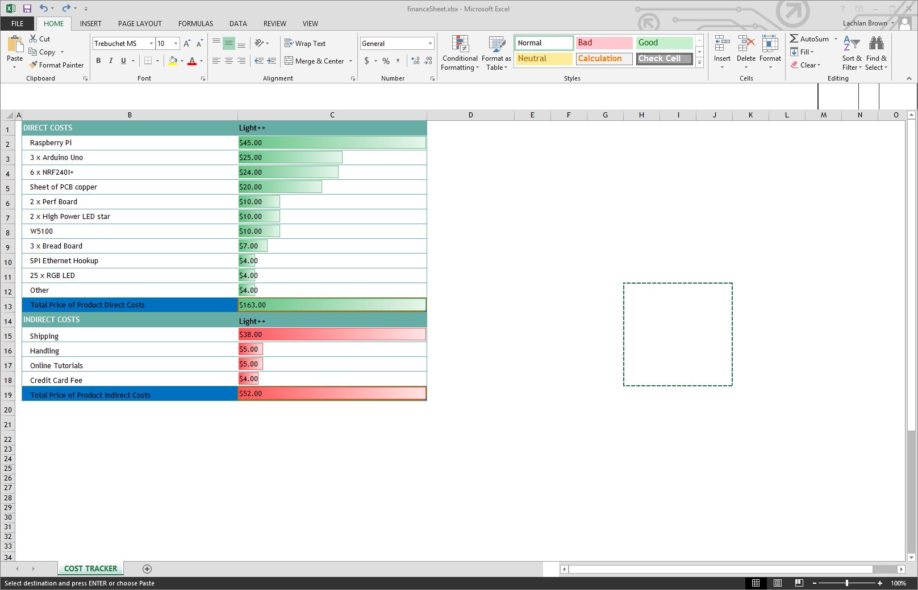

# 

# Project development and realisation

## Idea Generation

### Type of Product

I need to develop ideas for my intended system design. At this stage I have many ideas in mind, each with their own negatives and benefits. It is important to decide the direction now though, so I can focus on what needs to be done.

| Direction | Pro’s | Con’s | Evaluation |
| --- | --- | --- | --- |
| Build on top of a standard ceiling light | * Cheap * Easy to install * Familiar to the users | * Legal issues * Less control as a designer * Hard to develop | Taking this direction would create a possible successful product as all of the pros have something to do with the way the user view the product. It would be very difficult to develop this product though as all of the cons are negatives for the developer, making it very hard to develop. |
| Create an entire new system with my own lights | * Complete control as a designer * More features can be implemented * Design will seem complete as a whole, rather than an addition to an already complete product | * I would have to design an entire light * More concerns such as how to install and certifications | This direction is the best direction to go, because as a designer I can get more say in the product. It will be harder to develop than the other two, but the end result will be much better. |
| Have lamps around the house that are controlled | * Very easy to install * Cheap * Product is mobile | * Lamps do not look aesthetic all throughout the house * Lamps take up existing power points and use extra electricity, as ceiling lights are still in use when this product is being used | This direction does not seem good and not a direction I would like to go. It does not fit the need to the full extent, and will produce an unsuccessful product |

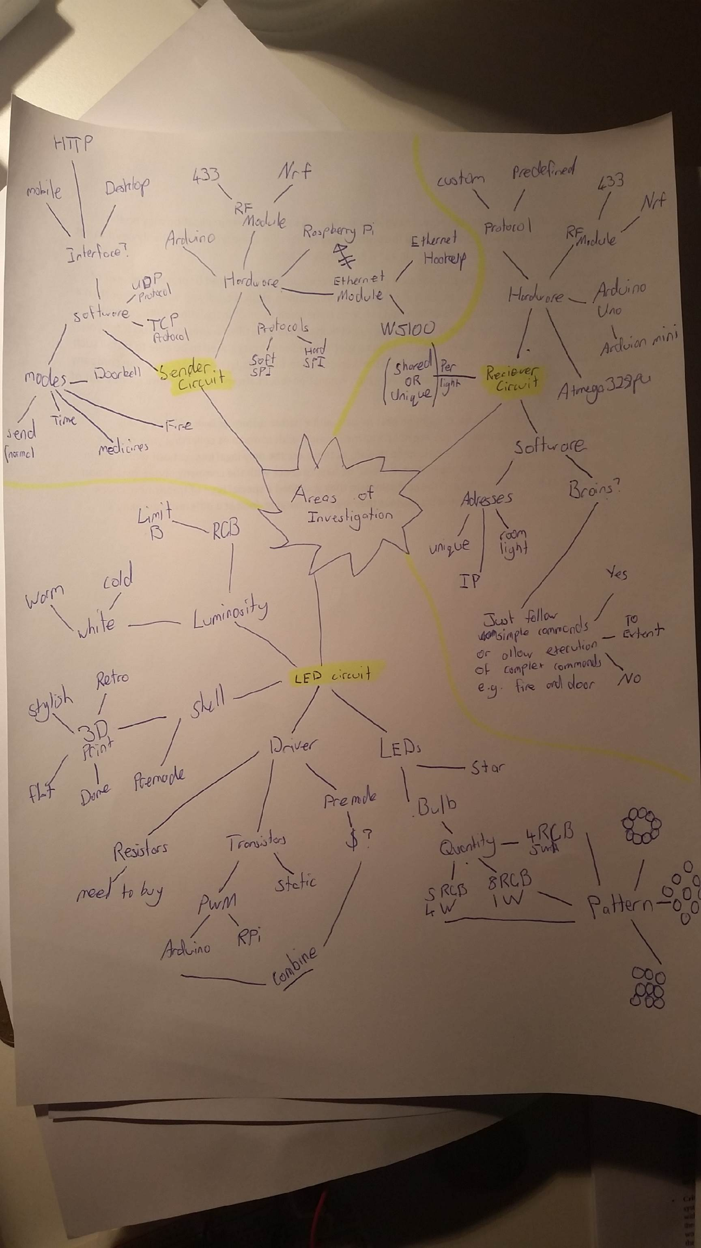Based on the above, I decided to design my project on creating an entire new system with my own lights. At this point I had many ideas on how I was going to complete each task. These ideas can became confusing when not written down, so I decided to create a mind map for the three different aspects highlighted below, that I will be designing. The mind map does not show the solutions to my problems, but instead shows the ideas that I have generated and the different paths I could take.

This mind-map greatly helped me put my ideas on paper, so I decided to make another one for the communication methods to be used in the system.

I decided to use a mind-map and flowchart hybrid to plan out how I was going to achieve the system communications as a whole (*see Schematic of Intended System on next page*). After mind mapping, I have concluded that the end product will consist of a phone connecting via Wi-Fi to a wireless router using HTTP, which will then send the data collected from the phone through an Ethernet cable to the RPi. The RPi will then process this data and then send that to the Arduino Uno using Serial connection. The Arduino Uno will then transmit this data using an RF module. The receiving Arduino Uno will pick up this data with its RF receiver. This Arduino will process the data then output the information through PWM to the light circuit.

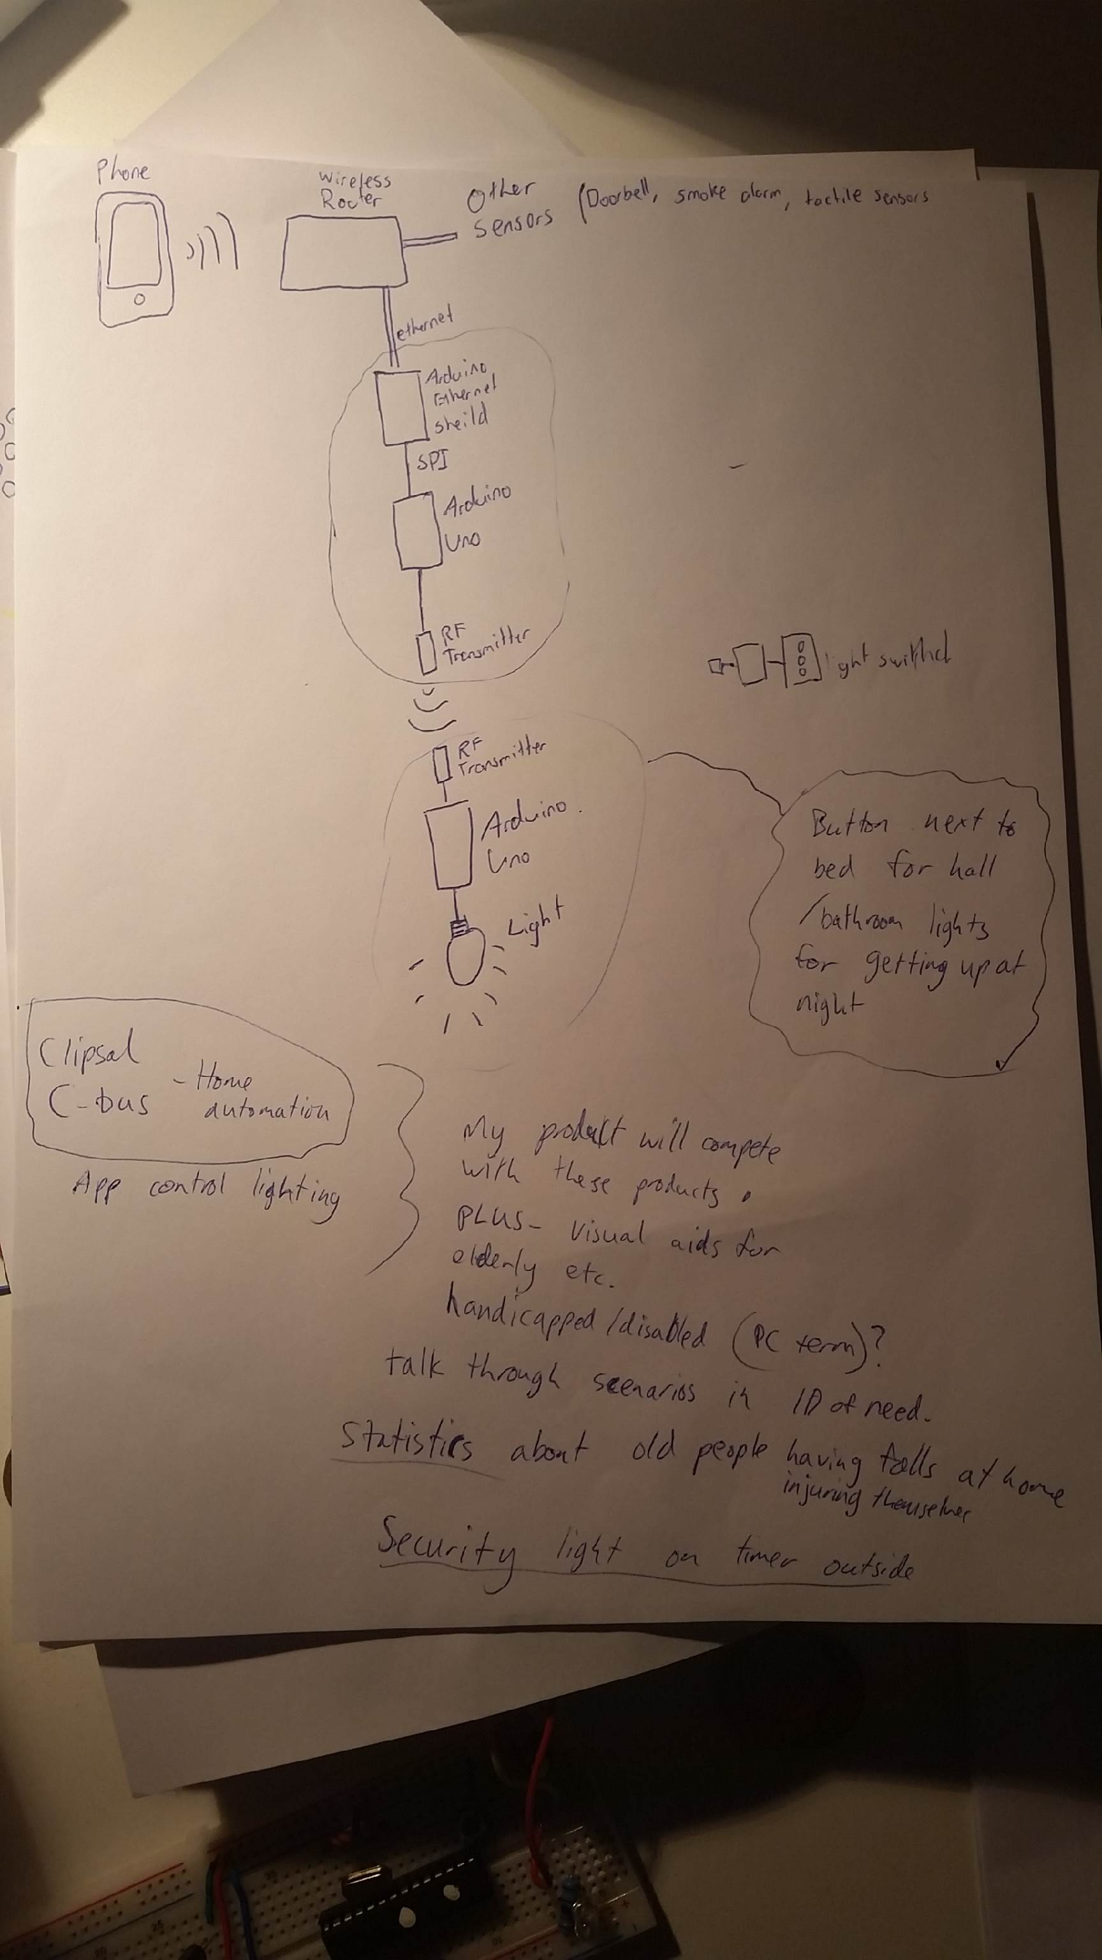

### Schematic of Intended System



### Inner Workings

#### Software of Ethernet Receiving Device

After testing different design solutions for the device to use as the Ethernet Receiver, I decided to use a Raspberry Pi (RPi). I programmed the RPi using python. The process of doing so was complex, but linear. There were no major problems I came across.

The software on the Raspberry Pi serves three different purposes, to get user input, to process the input, and output that in the communication protocol that the infrastructure can understand. Here is the list of the order of events that occur:

1. The Raspberry Pi (RPi) initialises a local server on the network
2. The RPi then waits for a HTTP request to be made
3. The RPi reads the users input and cuts out the bits it does not need
4. 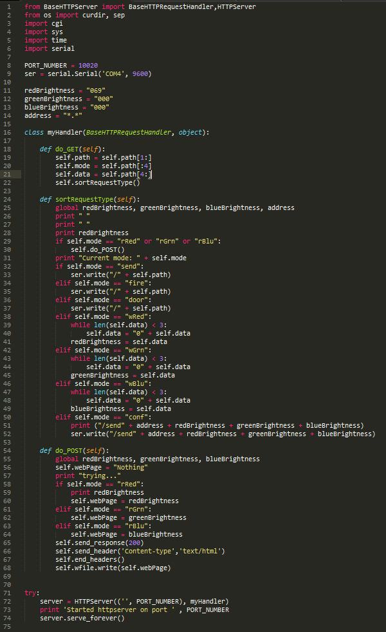The RPi then reads the first 4 characters of the data it has. These 4 characters will spell out the type of function that the user is planning on using. An example of this can be ‘fire’ or ‘door’.
5. The RPi then runs the corresponding function to what the user has asked for
6. The next 3 characters are read. These three characters are the address destination. The first character defines the room of the destination address, the second is for data accuracy, and the third is for the light address in that specific room. I will get into the specifics of the protocol after this.
7. The next 16 character are read, these are the data characters. The RPi will process these characters differently depending on the function that it is set to perform.
8. The next 2 characters are read. These characters are part of an error checking process to make sure the data is accurate.
9. After all characters have been read and processed, it is now time for the RPi to repack the data into respective format to be sent to the Arduino via Serial communication.

The protocol used for the sending of data through the network is of my own creation. Through my completion of the Information, Processes and Technology Board of Studies course I completed in 2013 I had adequate knowledge to do so. The protocol I made consists of 4 parts, the function type, the destination address, the data to process, and an error checking method similar to a checksum. An example data package sent with my protocol may look something like “send3.620000010000012”, to break down this data into information, here is what it does: Send the following information to the 6th light in the 3rd room, Red: 200, Green: 000, Blue: 100, White: 000 and check that it is correct with the error checking code of 12. This would result in the addressed light in lighting up into a purple colour. The error checking method is done by summing up all the characters in the data packet (excluding the last two characters, which are the error checkers) in their ASCII numerical values. After these values are added together, the number can for example 1539. When the number is over a 99 (a two digit number) the digits are then added together, like so: 1 + 5 + 3 + 9, which equals 18. 18 is now our error checking number that will be added to the end of the data packet.

#### Software of Arduino Sender

The software on the Arduino Sender serves four different purposes, to read the RPi Serial input, to read button input, to process the input, and output that in the communication protocol that the infrastructure can understand using radio frequency. Here is the list of the order of events that occur:

1. Forever wait until the RPi attempts to send something
2. Once the RPi sends data through Serial, read what it says byte by byte.
3. Optional error checking could be done here, but the chance of an error produced by the communication of Serial is almost 1 in a million, so it would not be worth checking as the error will be picked up later in the data’s journey <>.
4. Barely any processing is done to the data packets on the Arduino Sender. The only thing that is added is an End Char at the end of the transmission to signal the end of transmission. This is a special invisible char that has an ASCII value of 2.
5. The Arduino Sender goes through byte by byte and displays that onto radio frequency waves.

The sent data packet is almost identical to the one the RPi passes to the Arduino sender, albeit the end character that consists of the special End Char character.

#### C:\Users\Lachlan\Downloads\download.pngSoftware of Arduino Receiver

The software on the Arduino Receiver serves three different purposes, to read the Radio Frequency input, to process the input, and output that in Pulse-width modulation (controls the width of the pulse, formally the pulse duration allowing a varying voltage to be used. This varying voltage then allows the control of each LEDs brightness. It will later be referred to as PWM). Here is the list of the order of events that occur:

1. The Arduino waits forever until there is activity of radio frequency
2. The Arduino reads the data sent through radio frequency
3. The Arduino then processes this data and splits it into different bits, address, mode, data, and checksum
4. The checksum is then used against the data packet to validate it is correct
5. The Arduino then reads the address, and if it is its own addresses continues, if not the Arduino goes back to step 1
6. The mode is then checked and if it is either door, or fire modes they are executed specially. If it is a normal light adjustment the data is read and the different colours are lit up according to the data

### Circuit Creation

##### Processing Circuit

For prototypes 1, 2, and 3 Arduino’s were used for the processing circuit.

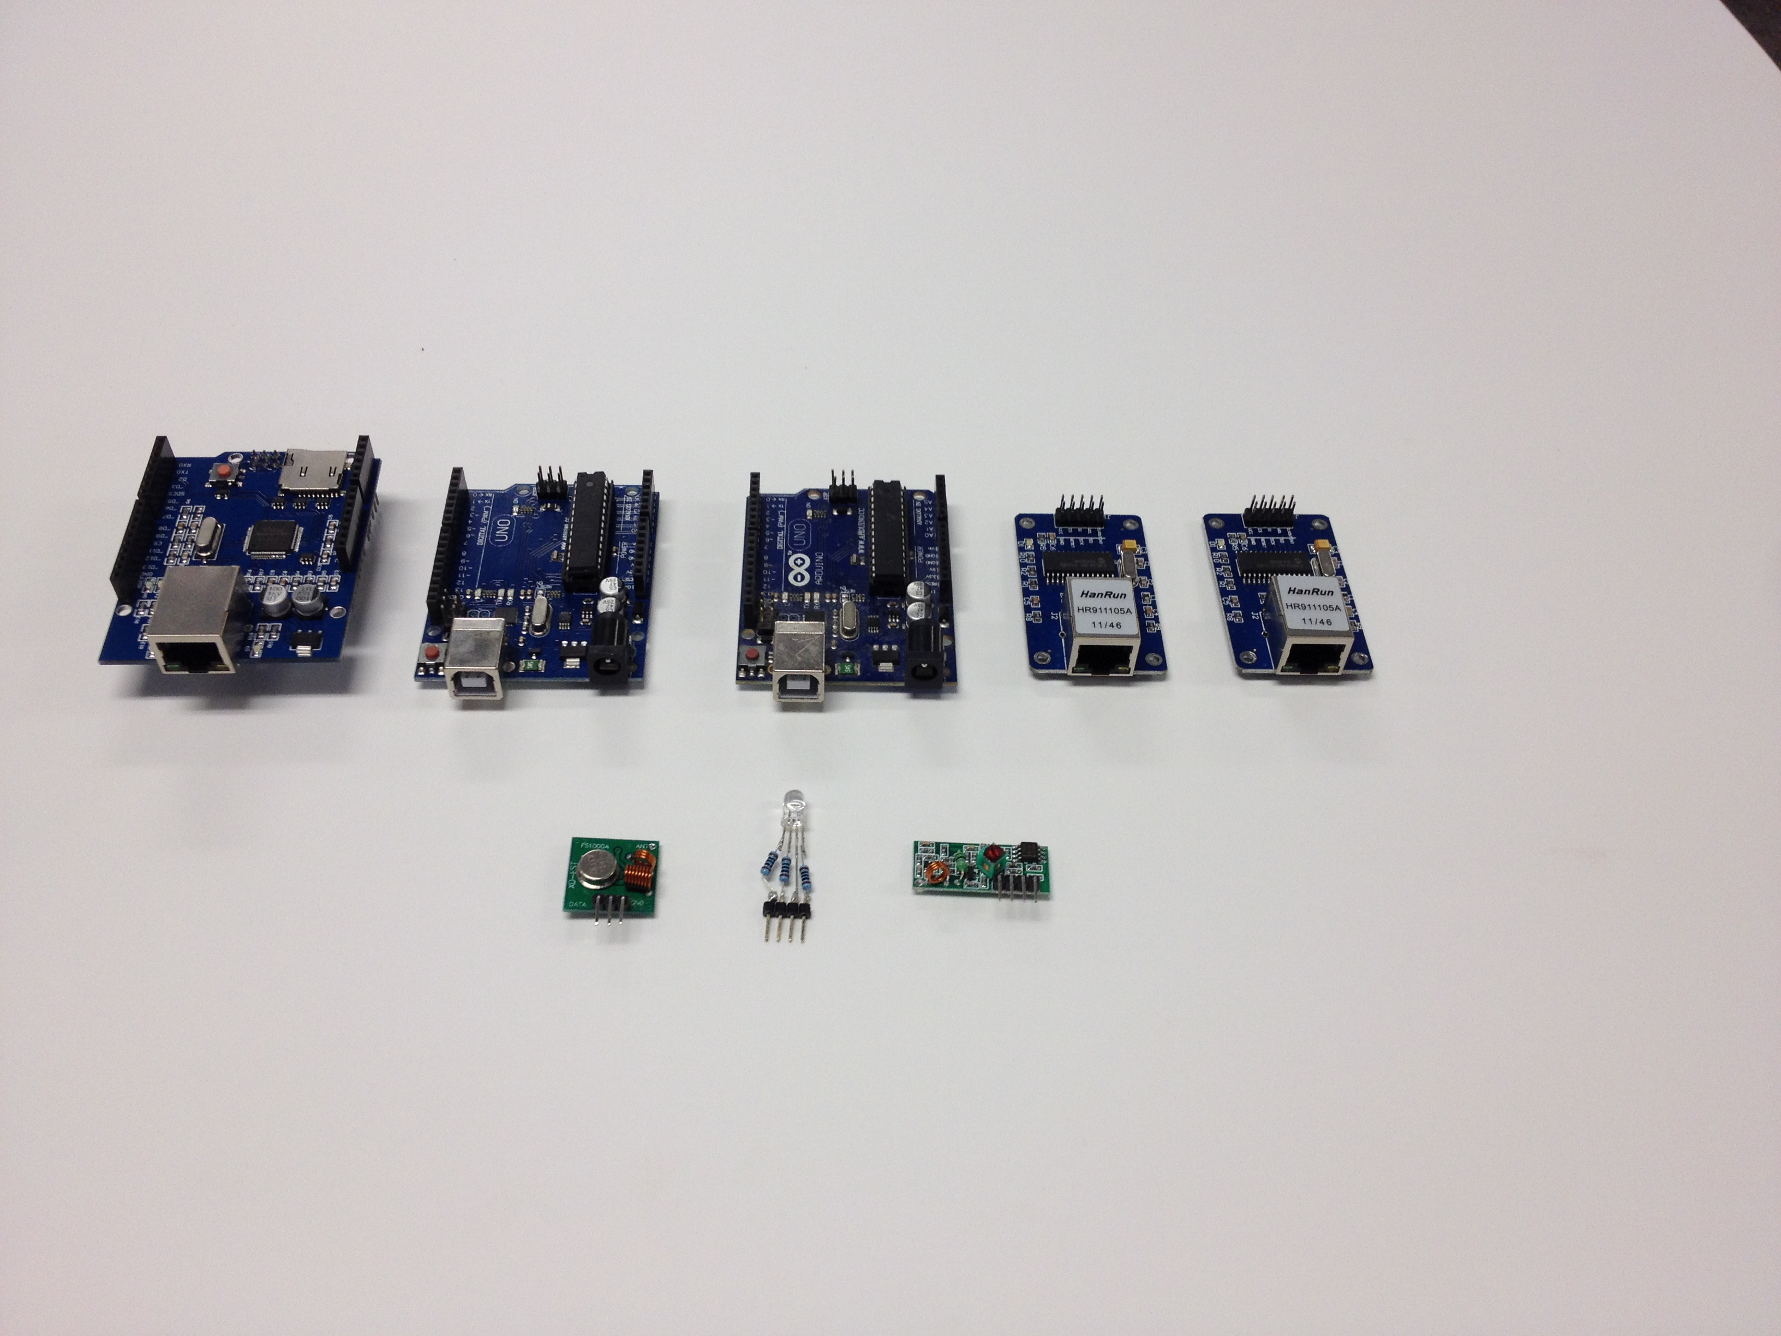

If my product was ever to become commercial success, the use of Arduino’s in the design could cause legal issues and will definitely raise the price of each light bulb. I decided instead to create my fourth prototype (prototype 3.5) with its own microprocessor circuit that was not the Arduino.

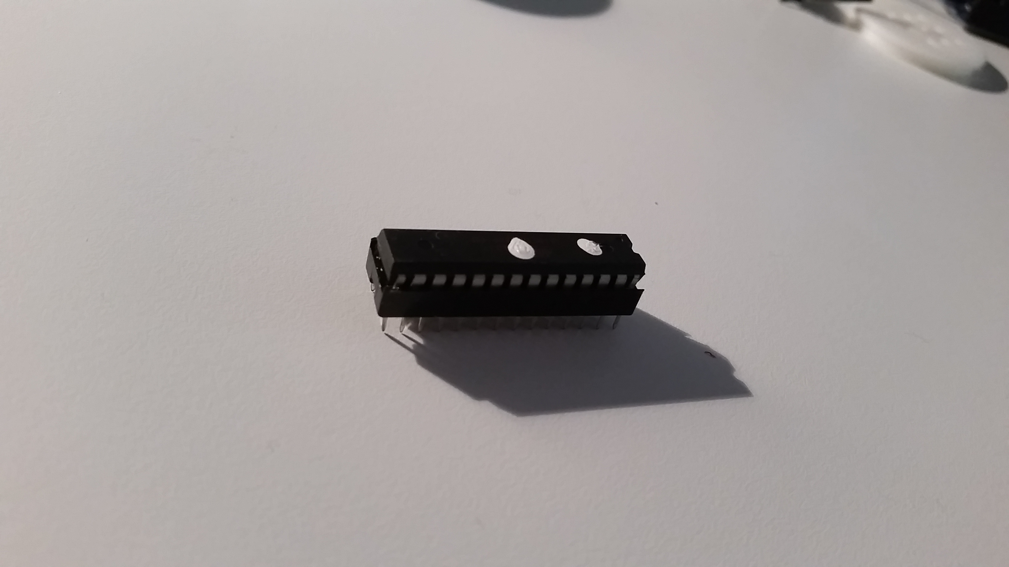

I used an atmega328PU as the microprocessor as it is the common favourite in the electronics community.

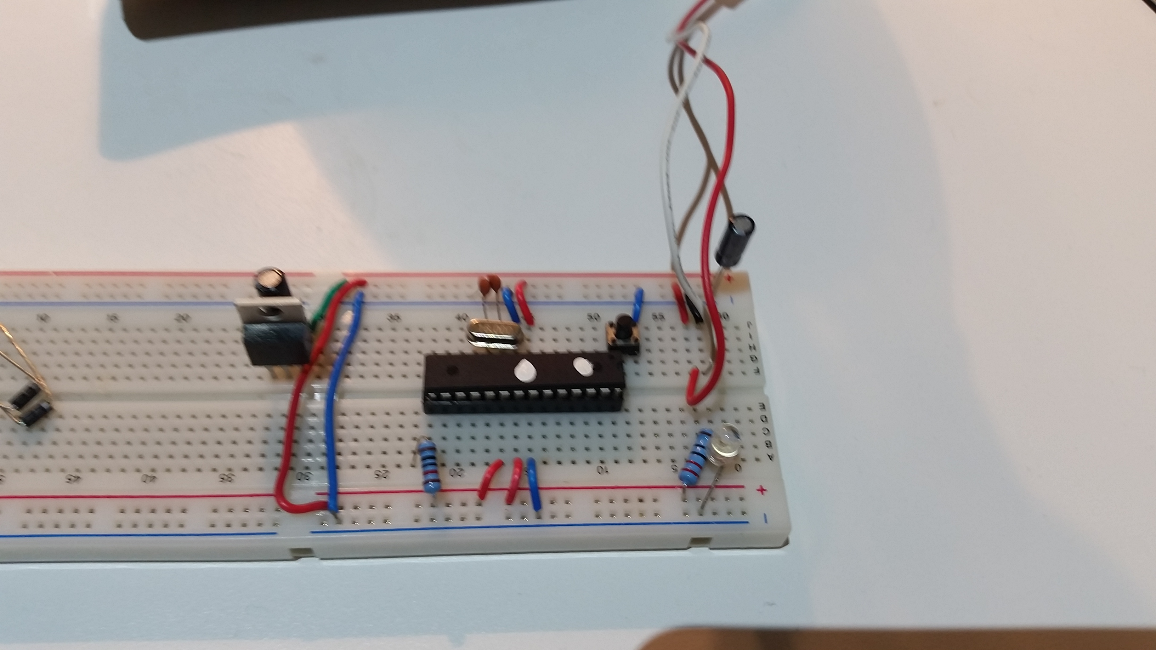

This is my final circuit. It consists of a 5V 0.5A power supply going directly to a 10uF capacitor. In the middle of the circuit is the microprocessor which has many connection to the power supply. It is connected to a 16MHz crystal which allows the processor to get it’s time right when using timed functions. To the left is a voltage regulator that steps the power down from 5V to 3.3V so I can run the RF module (which is not pictured). The benefits of this circuit was that in total it costed $4 when compared to the Arduino’s $15.

##### Light - Output Circuit

The output circuit was crucial that I got it right. All the other aspects I had completed so far were just background features that the user never gets to see. The full functionality the user sees is through this circuit, and a stuff up such as a wrong resistor value can cause the product to look like a failure. After countless hours, I developed this design. It uses PWM to allocate how much power each colour group gets through transistors.

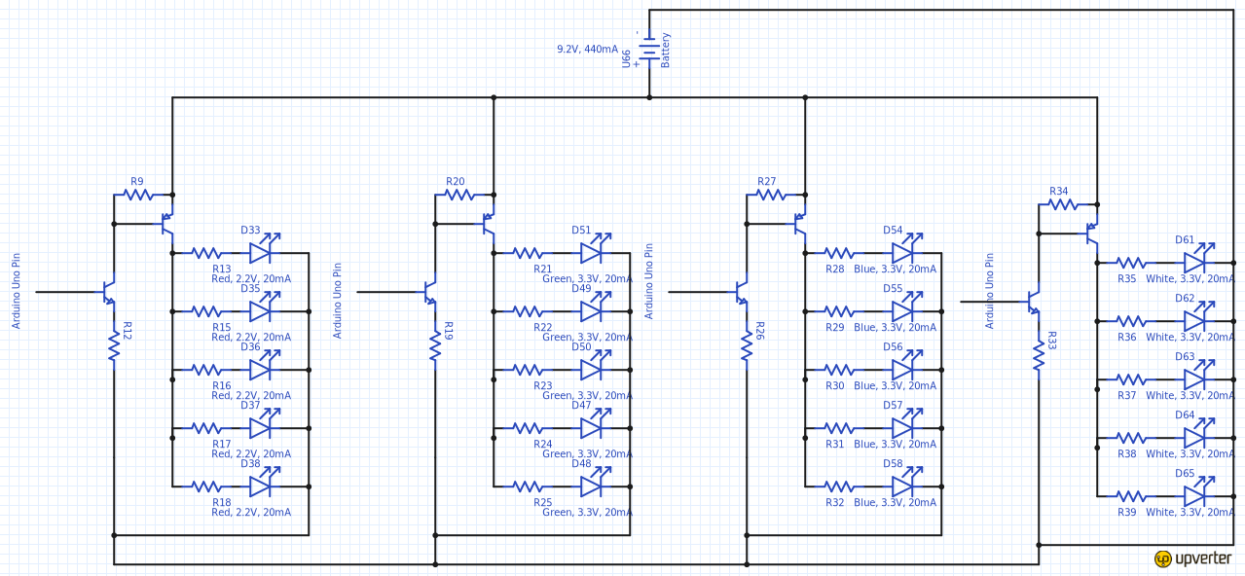

The circuit allows me to input anything between 5V and 10V and still get positive results, although the lower voltage I use, the lower resistor values I will have to use.

Here is a more simple view of how this will look like on a breadboard when driving a single LED.

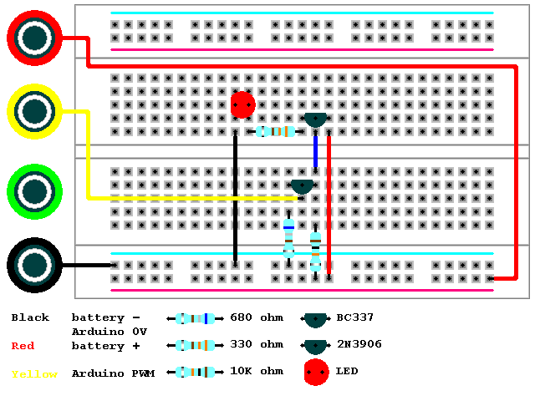

This test was a success and allowed an easy way for me to conceptualise in my mind how the final circuit will look.

Next I had to decide how the light fitting would look. I opted to go for a 3D print styled flat piece and a domed retro globe shape.

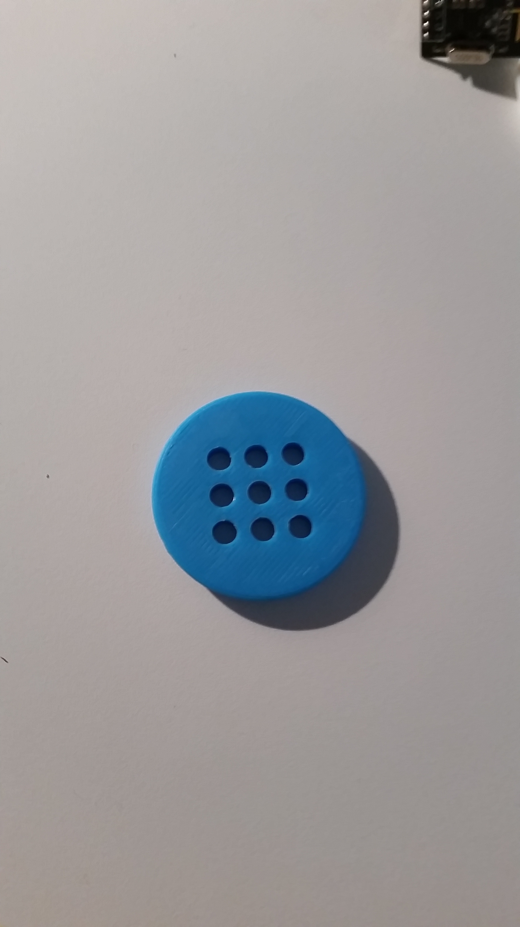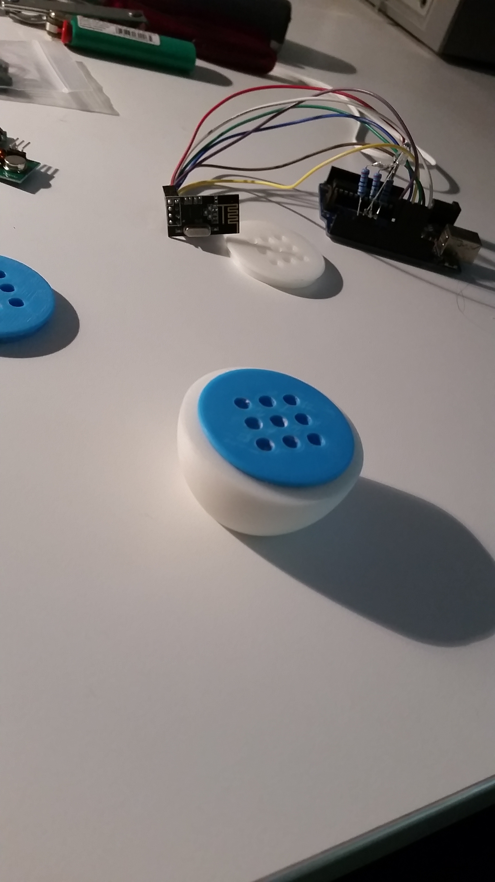

After evaluating I realised that blue did not fit the design of the product, and decided to use a white flat print instead.

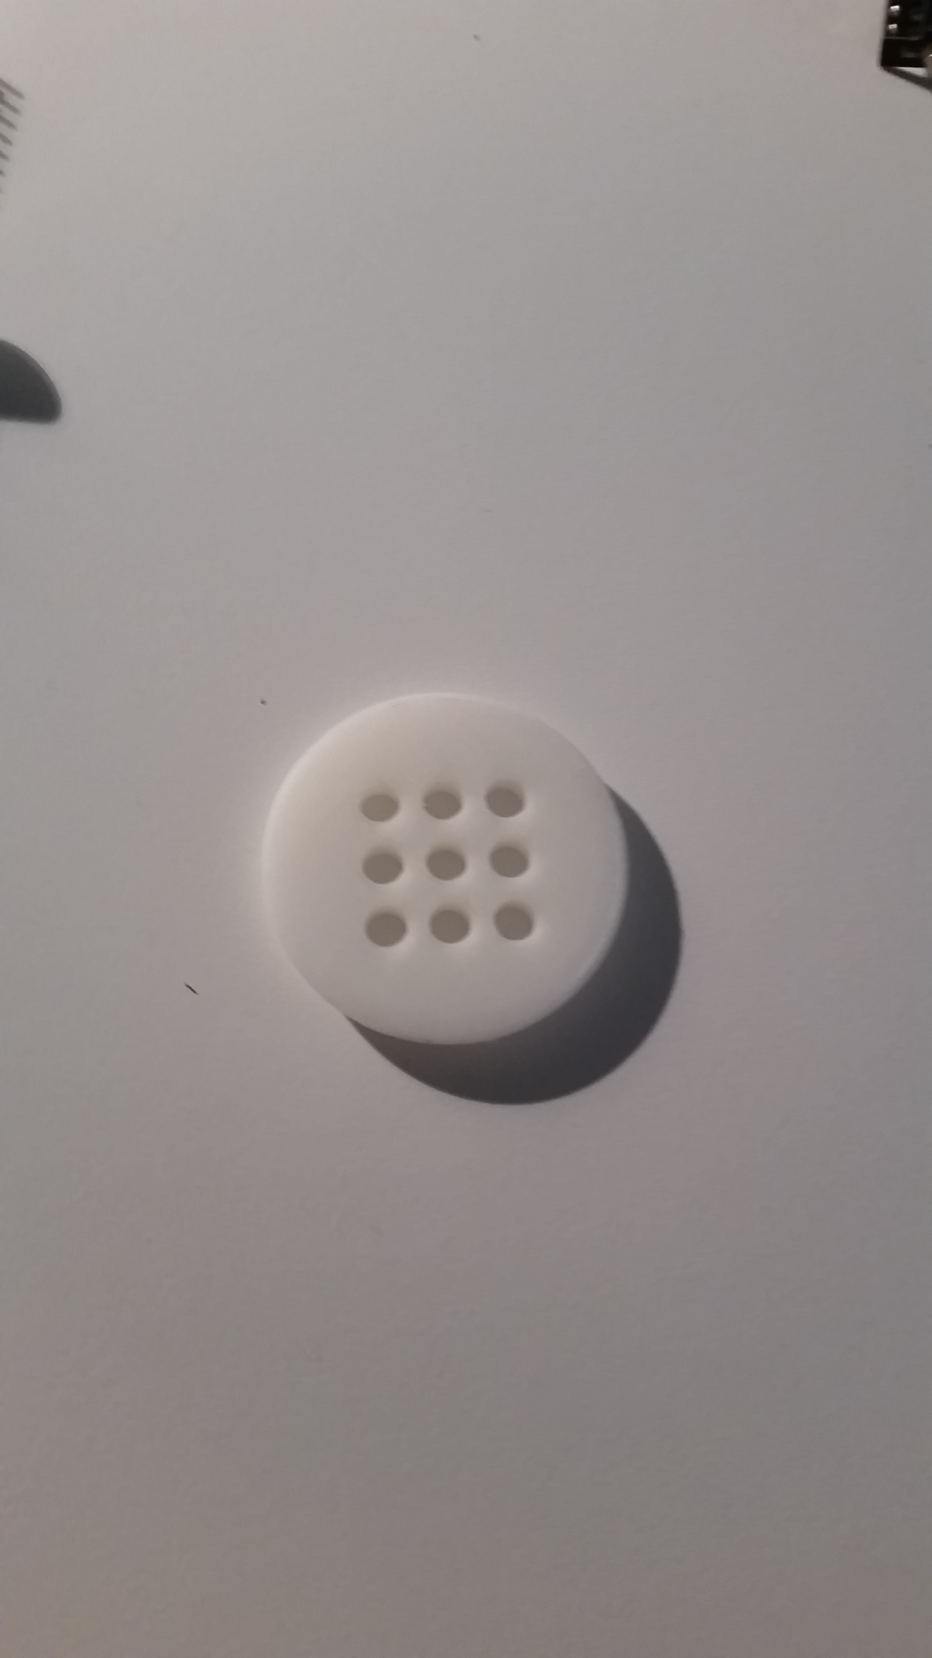

## 

## Exploration of Existing Ideas and Degree of Difference

It was important to know what existing ideas were already out there, as it helped me further develop my product. I found there were two types existing products out there, synergistic products and competing products.

### Synergistic Products

These are products that I discovered that will help me achieve my final product by giving more value to my product through the use of the other. A very interesting synergistic product that I found was NetIO, a phone app available on the Apple App Store and the Google Play Store. The app allows a user to create an interface of interactive elements such as buttons and sliders which send HTTP requests to a designated IP address. This is interface can then be used as a wireless remote to control a server (my RPi).

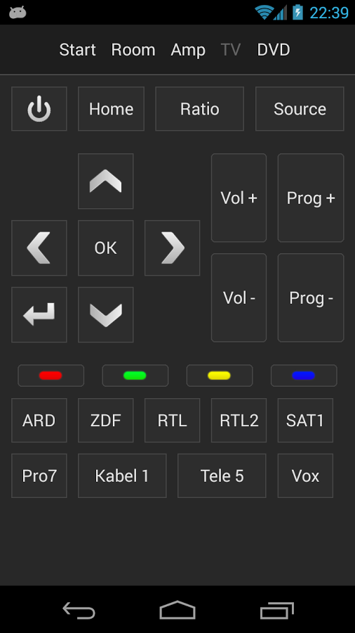

After finding this existing idea which could act as a framework, I decided to email the developer to see if it was possible for him to add a feature. I also asked him to review my product so far, as he is an expert in the field:

Me:  
“Hi there,   
I am currently creating a major project for my last year of school. Your app is what I am using for communication, but I was just wondering when the RGB colour picker will be released for the NetIO app, as it will make my project much more better. Is there any chance I could get a beta version of it, if it's already in development? (Android)

If so, thank you! If not I understand.

Regards,   
25313399”

Developer:

“Hi *25313399*,

Thanks for your mail. I saw you are already working on three sliders to set the colour! The colour-picker is the next item we are going to implement. However, my brother who is developing the android app is on holidays for a few weeks now as he graduated a couple of days ago ;)

We can invite you to beta testing, however the colour-picker will come in September or October... (But not guaranteed!)

I suggest using sliders (and make them coloured in red/green/blue) as I did in my living room (see attachment)

Best regards

David”

Me:

“Hi David,

Thanks for your fast reply! I am using the sliders but they are not quite working as I expected and they can be a bit buggy.

Are there any other solutions to this problem that you would suggest?  
  
Also, for my project that we talked about earlier, is there any chance you could give it a quick review and evaluation? It would help me majorly! I have attached relevant documents.

Regards, 25313399”

Developer:

“Hi again 25313399,

I would suggest maybe using 3 different buttons instead for each colour, one for off, another for half brightness and another for full brightness. This is an easier solution, but still with great functionality.

I would love to review your project! (So long as you share it on the NetIO forums!)

I very much like the design of the communication you have used from RPi to Arduino then RF to another Arduino. I might suggest though that you do not send too much data through these too fast, as the NetIO app might freeze up, and so will the receiving Arduino.

You also might want to look at using Common Anode RGB LEDs instead of Common Cathode next time to save on component use.

Please keep me updated on this project, as it looks very interesting!

Best regards

David”

The product I sent him was my 3rd prototype. He gave sound advice so I decided to implement it into the 3rd prototype, which resulted in Prototype 3.5.

### Competing Products

Competing products are products that have already entered the market and are trying to fill the same need as my product. If I evaluate each product and find their strengths and weaknesses, I can build on those to create a product that is better than theirs overall. Following my analysis, the following spider chart highlights how my final product compared to the existing competing products.

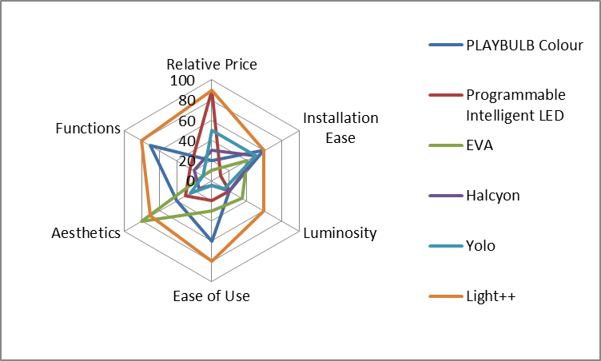

|  |  |  |  |  |  |  |
| --- | --- | --- | --- | --- | --- | --- |
|  | PLAYBULB Colour | Programmable Intelligent LED | EVA | Halcyon | Yolo | Light++ |
| Relative Price | 20 | 90 | 10 | 30 | 50 | 90 |
| Installation Ease | 60 | 10 | 40 | 50 | 50 | 60 |
| Luminosity | 20 | 20 | 35 | 20 | 15 | 60 |
| Ease of Use | 60 | 20 | 30 | 5 | 5 | 80 |
| Aesthetics | 40 | 30 | 80 | 15 | 25 | 70 |
| Functions | 70 | 25 | 10 | 20 | 10 | 80 |

The Yolo, and Halcyon systems did not prove to be a competitor to my product, as their solutions were flawed and poor. However, the other three systems each posed a strong aspect that would be a challenge to beat. This included PLAYBULB Colour’s function, ease of use, and installation ease. This product succeeded in these aspects as it created an elegant and simple design that was feature rich and allowed self-installation. The Programmable LED offered a challenge as well, with its relative price being very competitive. Per bulb, the cost was $40 which is more than what I proposed but the reason it has such a good relative price is that there is no computer system, so the bulbs are all that needs to be purchased, unlike mine where you have to pay $100 for the computer system. The EVA really had me in awe at its appearance, and it was obvious the amount of time that had gone into crafting it. There was no way I could beat the aesthetic nature of the EVA product.

## Consideration of Design Factors Relevant to the Major Design

| Factors Affecting Design | Description | How I have applied this factor |
| --- | --- | --- |
| Needs | Build a system that delivers a visual alert in place of an audible alert | I have addressed this factor by building an automated light system which can be controlled through external events such as a doorbell or fire alarm |
| Function | To flash the lights in a user defined pattern to signify something has happened, such as the fire alarm has gone off or someone has pressed the doorbell. | Using guidance from my criteria to evaluate success, I have systematically worked through my project to achieve this function successfully |
| Size of Light Fitting | The size of the light fitting must be kept small so that it can fit into a standard sized hole in the ceiling. | I have applied this factor by carefully making sure no parts of my project are more than 7cm wide |
| Luminosity of Light | The light must be bright enough to replace a standard ceiling light, as my product aims at replacing the standard ceiling light. | I have applied this factor by measuring luminosity using a special sensor. |
| Limitations of Wireless Communication | There are many limitations to wireless communication, especially radio frequency communication. | I overcame this issue by ensuring I was within the maximum range of the transmitter, and adding an error checking method to ensure the data was accurate |
| Cost | The unit needs to be cheap and a cost effective solution but still do the job appropriately. It is estimated that my product will cost approx. $1000 but can be done cheaper if I purchased parts in bulk, and got it manufactured in a country like China. | I have achieved this by sourcing cheap materials and not over charging for the product |
| Quality | The quality of my design is a very important factor as if my design fails, a whole range of scenarios could happen, such as short circuiting and causing a fire in the roof | I did lots of testing on various components to ensure they were of high quality. I also made 4 prototypes, each increasing in quality. |
| Durability | Durability is not a main concern of my product as it is always stationary. It does need to live a long time though | I used suitable parts and tested them multiple times |
| Aesthetics | The product as a whole does not need to look good, but the 3D print that holds the LED light does | I made certain that the displays looked good, so that the product got a good impression |
| Use of design | The device will be used in place of an audible alert | Using guidance from my criteria to evaluate success, I have systematically worked through my project to achieve this function successfully |
| Sustainability | Unfortunately my product is not very sustainable as it uses many electronic components | This factor could not be applied |
| Energy | The product does not use much energy at all. Standard ceiling globes are typically 50W, my product is 1.5W | I have applied this factor by using LEDs instead of bayonet lights. |
| Recyclability | The product can only be recycled if the user knows how to correctly re-use electronic equipment. | This factor could not be applied, but instead the user can choose whether to apply it or not through their own recycling plan |
| Personal Value | Very often I am in my room with my music up loud, and I miss the doorbell. This is annoying and I can relate to how my grandmother must feel. I will be using this product in my own room when I get it back. | N/A |
| Obsolesce | My product will not become obsolete for a long time as LEDs are just becoming popular in households now. Next automated lights will be become popular, so my product has a long time to go before it is obsolete. | I have applied this factor by creating an innovation that will become popular in the future, increasing it’s time to obsolescence. |
| Life Cycle Analysis | I have designed my product so it has a 90% re-use rate from cradle to grave. | I have applied this factor by making it easy for the components of the light to be swapped out with ease. |
| Ergonomics | I have carefully considered many ergonomic factors, such as if the lights are flashing too fast and severely it could cause epilepsy | I have applied this factor by programming smooth and gradual changes into the lights code, this gives a nice easy feel. |

## Appropriate Research and Experimentation of Materials, Tools, and Techniques

### Industrial vs School Based Production

| Production Method | Why I need the method | Commercial and industrial process | What I did, given cost and scale limitations |
| --- | --- | --- | --- |
| Acid etching PCBs | To etch my PCB for the final prototype. | Uses a retail acid etching bath that makes the process safer, more controlled and easier. This process will also allow for a more strengthened PCB, due to the timing of the PCB being removed from the acid. | I used a lunch box that was made out of plastic that could withstand the acids effects. |
| PCB design printing | To draw the circuit onto the un-etched PCB. | A machine that automatically prints a digital image onto a PCB | I used a DALO Pen to draw the design of my circuit onto the PCB |
| Component Soldering | To connect the components of my project onto the PCB, and connecting PCBs to one another. | Automated inductive soldering machine to quickly and efficiently solder the components automatically. | I used a soldering iron, soldering stand, and solder. I had to carefully place each component and solder it to the board, while obeying safety procedures. |
| Component Testing | To ensure all the components I used were fully functional, before adding them into my circuit. | In an industrial setting, an automatic component tester is used, which automatically places the component into a testing circuit to ensure it is of quality. The machine then throws away the bad ones, and keeps the good ones. | I had to build individual circuits for each type of component to ensure the component was working as intended. |
| 3D printing | To create a standard light bulb shaped base for my LED's to fit into. The standard size allowed this fitting to replace other standard light bulbs in their sockets. | Uses an industrial 3D printer to get a more accurate final product. | I 3D printed a base for the LED's using a private 3D printer which uses a low density plastic that was not as accurate as I needed it to be. |
| Table Sawing | To cut the wood used for the housing demonstration accurately. | A better industrial table saw could be used to cut thicker and heavier materials for a better final display. | Mr Parker used the table saw to accurately cut the large pieces of wood. |
| Putty + Sanding | To smooth out the inaccuracies of the house demonstration I built out of wood. | Putty and sanding would not be needed when using an industrial table saw, as the cuts would be more accurate, thus disallowing for any discrepancies when measuring and cutting the wood. | I used putty to conceal the cracks in the display I made, and used an electric orbital sander to sand back the excess putty so the box was completely smooth |
| Breadboard Prototyping | To quickly and easily connect components to test different circuits. | The use of software simulations | I used a breadboard (prototype board) to continuously evolve my circuit. |
| Purchasing of products | To get components I could use in my MDP | In an industrial setting, components in the 1000s can be purchased, saving lots of money by buying bulk straight from the manufacturers in such marketplaces as Alibaba. | I purchased most of my components at Jaycar Electronics and Tayda Electronics. These places resell their stock for much higher than what they purchased it for. |
| Gathering information | To find data about my target market, and to discover what makes a good product in the target market. | In an industrial setting companies could offer an incentive for people who accurately fill out my forms. | To gather information I had to interview nurses, the elderly, and caregivers; many of whom did not seem too happy to participate in the surveys |

## Testing of Design Solutions

### Functional and Aesthetic Considerations

| Aspect | Priority | Why this is important to the success of the design process |
| --- | --- | --- |
| Easy implementation / install | High | In order to be successful, the  Product needs to be easy to implement. This includes how easy it is to install, and how easy it is to connect it to the various sensors. |
| Consumer Approval | High | To be considered a success this product must get a positive response from the target market. |
| All in one solution | High | To be a success the product must be able to work without any use of additional competing products. |
| Intuitive | High | The product must be able to function correctly when used by a beginner with no previous knowledge. |
| Improves on existing competing product | Medium | Must contain all features out there that similar products use, plus more additional features. |
| Shape and Form | Low | Although not a high priority, the aesthetics of the product can greatly influence a customer’s thought on the function of the product. |
| Luminosity | High | For the product to be a success it must be able to replicate the light intensity of the standard ceiling globe. |
| Colour Range of Light | High | To be a success the product must be able to replicate many different light colours. Some LEDs cannot do this, so I need to be sure to find the right LEDs |

### Radio Frequency (RF) Device to Use

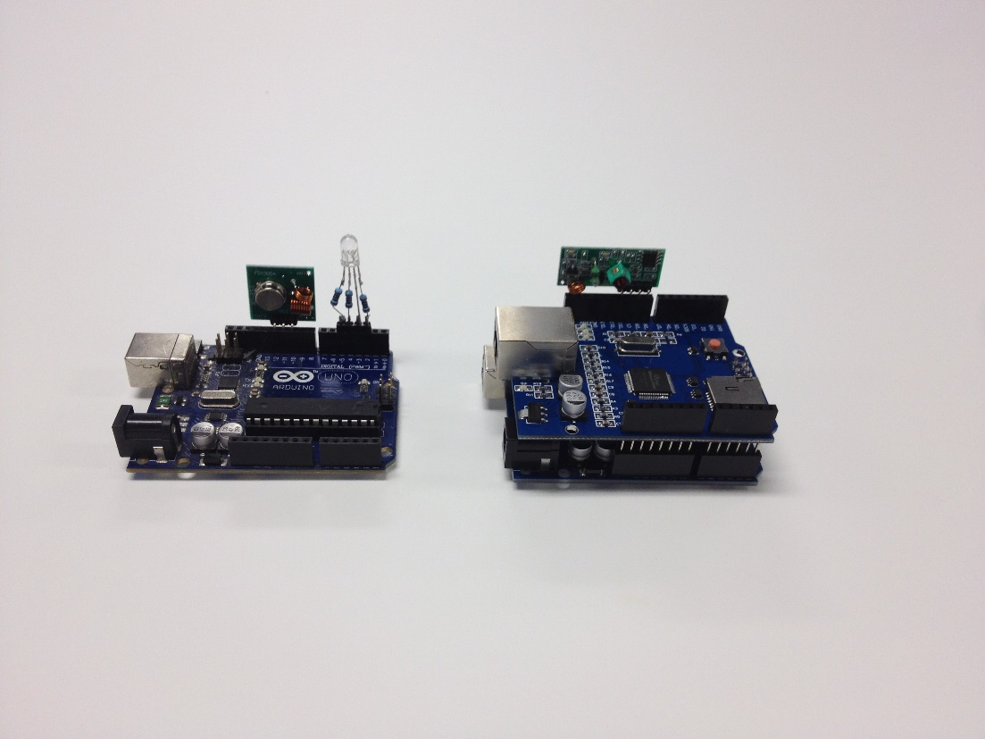I had the choice of two different RF transceivers, the 433Mhz RF transmitter and receiver (which will be referred to as 433), and the Nrf24L01 transceiver (which will be referred to as Nrf) for the wireless communication method. The 433 consists of 1 transceiver and one receiver, whereas the Nrf consists of just one transceiver, where 2 is required for communication. To find out which one would best suit my product, I ran a few tests on each device:

#### Range Minimum Test

##### Aim

To test what the minimum distance is that the two different RF devices can communicate with data accuracy over 90%. This will allow me to know where to install the communication modules when installing the system.

##### Equipment

* 2 x Arduino Uno w/ Power Supplies
* 1 x LCD screen
* 1 x LED
* 1 x 433
* 2 x Nrf
* 1 x Push Button
* Various Wires
* Tape Measurer

##### Procedure

1. Write code for communicating test packets of data, and displaying accuracy on the LCD screen of the receiving Arduino. Pressing the push button will send 1 data packet from the sender to the receiver.
2. Set up the two Arduino’s at a set distance apart using the tape measure (I used 10m because of prior knowledge)
3. Press the push button
4. If the LCD is showing the accuracy is greater than 90%, half the current distance and go back to step 2. If the accuracy is less than 90% move the Arduino’s back half the distance they were moved towards each other before.
5. After repeating steps 2, 3, 4 a definite distance will be found where the RF devices cannot communicate with a 90%+ accuracy
6. For a last check that the distance is right, a 10% check is used, where the Arduino’s are setup 10% close than the perfect distance and tested. The accuracy should be below 90%. Then the Arduino’s are setup 10% back from the perfect distance. The accuracy should be greater than 90%, or even equal. If these two conditions are not met, step 2, 3, 4 should be repeated more.

An example of this procedure with the 433 looked like:

* 433’s at 10m gave 95% accuracy
* Moved forward to 5m distance
* 433’s at 5m gave 94% accuracy
* Moved forward to 2.5m distance
* 433’s at 2.5m gave 94% accuracy
* Moved forward to 1.25m distance
* 433’s at 1.25m distance gave 88% accuracy
* Moved back to 2m distance
* 433’s at 2m distance gave 92% accuracy
* Moved forward to 1.5m distance
* 433’s at 1.5m distance gave 90% accuracy
* Moved back to 1.6m distance
* 433’s at 1.6m distance gave 91% accuracy
* Moved forward to 1.4m distance
* 433’s at 1.4m distance gave 89% accuracy

##### Safety

Going in to this experiment, I did not have many safety concerns other than the radiation RF transmitters give off. I combatted this safety concern by making sure I never had my head too close to the transmitter while it was on and sending data.

After going through the procedure, I accidentally cut myself on the tape measurer while winding it back up. This was careless of me, and through evaluation I have decided that it would be a good idea to take more care around the tape measurer and wear gloves when winding the tape back in from a distance greater than 5m.

##### Discussion

The procedure requires a bit of common sense to come to a conclusion where a definite answer is given, this is poor design if this procedure was made public. Another flaw in this experiment is the fact that one of the modules may have been broken and not working to its full potential. I combatted this by doing multiple test, each time using different hardware modules. A better way I could have done this test was to have multiple receivers that found the average between them, instead of relying on a single receiver.

##### Conclusion

I concluded that the 433’s minimum sending distance with an accuracy greater than 90% is 1.5m. This is a very large distance when compared to the conclusion of the Nrf’s minimum distance of 5cm. Although comparatively, the Nrf was much better than the 433, anything less than a minimum of 3m is needed for this product to be successful when installed correctly. So in all, the Nrf wins as it allows for human error when installing the modules if two modules are too close.

#### Range Maximum Test

##### Aim

To test what the maximum distance is that the two different RF devices can communicate with data accuracy over 90%. This will allow me to know what the maximum coverage distance is for each RF module and allow me to install the system to its fullest potential.

##### Equipment

* 2 x Arduino Uno w/ Power Supplies
* 1 x LCD screen
* 1 x 433
* 2 x Nrf
* 1 x Push Button
* Various Wires
* Tape Measurer

##### Procedure

1. Write code for communicating test packets of data, and displaying accuracy on the LCD screen of the receiving Arduino. Pressing the push button will send 1 data packet from the sender to the receiver.
2. Set up the two Arduino’s at a set distance apart using the tape measure (I used 15m because of prior knowledge)
3. Press the push button
4. If the LCD is showing the accuracy is greater than 90%, move the Arduino’s back 5m. This step should be repeated until the accuracy is less than 90%.
5. By finding where the accuracy is 90%, a 10% distance check should be used. The Arduino’s are setup 10% close than the perfect distance and tested. The accuracy should be above 90%. Then the Arduino’s are setup 10% back from the perfect distance. The accuracy should be less than 90%. If these two conditions are not met, step 4 should be repeated more.

##### Safety

Going in to this experiment, I did not have many safety concerns other than the radiation RF transmitters give off. I combatted this safety concern by making sure I never had my head too close to the transmitter while it was on and sending data.

After going through the procedure, I accidentally cut myself on the tape measurer while winding it back up. This was careless of me, and through evaluation I have decided that it would be a good idea to take more care around the tape measurer and wear gloves when winding the tape back in from a distance greater than 5m.

##### Discussion

The procedure requires a bit of common sense to come to a conclusion where a definite answer is given, this is poor design if this procedure was made public. Another flaw in this experiment is the fact that one of the modules may have been broken and not working to its full potential. I combatted this by doing multiple test, each time using different hardware modules. A better way I could have done this test was to have multiple receivers that found the average between them, instead of relying on a single receiver.

##### Conclusion

I concluded that the 433’s maximum sending distance with an accuracy greater than 90% is 30m. This is a very small distance when compared to the conclusion of the Nrf’s maximum distance of 50m. To conclude, it would be very difficult to use the 433’s in my product as it would mean more sender modules would need to be positioned around a large house to get the house full coverage. With the 50m sending distance of the Nrf, it makes the product a lot simpler as 1 single sending module can be used to cover a circle with a diameter of 100m. The Nrf was much better than the 433.

#### Rate of Messages Received Test

##### Aim

To test how many data packets can be received using each RF module in a 10 second period. This will let me know how often the system can send light commands to output modules.

##### Equipment

* 2 x Arduino Uno w/ Power Supplies
* 1 x LCD screen
* 1 x 433
* 2 x Nrf
* 1 x Push Button
* Various Wires

##### Procedure

1. Write code for communicating test packets of data, and displaying packets received on the LCD screen of the receiving Arduino. Pressing the push button will send 1000 data packets from the sender to the receiver in the duration of 10 seconds evenly spaced out.
2. Space the Arduino’s out at a 10m distance
3. Press the button
4. Wait 10 seconds
5. Record the number on the LCD screen
6. Repeat steps 3, 4, 5 five times in total
7. Average the 5 recordings and this is the final score

##### Safety

Going in to this experiment, I did not have many safety concerns other than the radiation RF transmitters give off. I combatted this safety concern by making sure I never had my head too close to the transmitter while it was on and sending data.

##### Discussion

The procedure gives a very good representation of the how many messages can be sent across 10m to each RF module. A flaw in the design though is that one RF module may be better at the 10m mark than the other one. A way to combat this would be to test the rates at 5m, 10m, 20m, and 40m to get a more accurate reading.

##### Conclusion

I concluded that the Nrf was much better than the 433 in this test. The Nrf allowed for 50 data packets to be received per second, whereas the 433 only allowed 20 data packets per second. This is very good to know as it allows me to have the lights update much faster if the user wishes to manual scroll through the lights colours smoothly, whereas the 433 may not look as smooth.

#### Accuracy of Messages Received Test

##### Aim

To test how accurately the packets are received from a 10m distance. This will let me know to what extent I’ll need to include an error checking method such as a checksum.

##### Equipment

* 2 x Arduino Uno w/ Power Supplies
* 1 x LCD screen
* 1 x 433
* 2 x Nrf
* 1 x Push Button
* Various Wires

##### Procedure

1. Write code for communicating test packets of data. Pressing the push button will send data packets from the sender to the receiver for the duration of 100 seconds at a rate of 5 packets per second. The receiving Arduino knows what the data packets consist of and marks how many correct packages are sent and how many incorrect packages are sent.
2. Space the Arduino’s a distance of 10m
3. Push the button
4. Read the number off the LCD screen

##### Safety

Going in to this experiment, I did not have many safety concerns other than the radiation RF transmitters give off. I combatted this safety concern by making sure I never had my head too close to the transmitter while it was on and sending data.

##### Discussion

The procedure gives a very good representation of the how accurately messages can be sent across 10m to each RF module. A flaw in the design though is that one RF module may be better at the 10m mark than the other one. A way to combat this would be to test the accuracy at 5m, 10m, 20m, and 40m to get a more accurate reading.

##### Conclusion

To conclude, the 433 received 474 correct packages out of the 500 sent. This amounts to a 95% accuracy rate. The Nrf received 491 packets correctly out of the 500 sent. This amounts to 98% which is a much higher rate than the 433. I was hoping for 100% accuracy rate so I would not have to include an error checking method, but with such a high accuracy rate I can use a simple error checking method such as a checksum.

#### Power Consumption Test

##### Aim

To test how much power each of these RF modules consume. I need to know this for when I design a circuit that uses one of these modules.

##### Equipment

* 1 x Arduino Uno w/ Power Supplies
* 1 x 433
* 1 x Nrf
* Various Wires
* Multimeter

##### Procedure

1. Write code for communicating test packets of data. The packets will automatically be sending every 100ms.
2. Measure the voltage that the device is using by putting the Multimeter in parallel with it. Take the average reading over 10 seconds
3. Measure the amperes that the device is using by putting the Multimeter in series with it. Take the average reading over 10 seconds

##### Safety

Safety is very important when dealing with live currents in the way that I am here. It is very important to always double check there are no loose live wires and that the circuit does not exceed 9V in total, or 5A.

##### Discussion

At first the readings seemed to fluctuate a lot for me, this was due to my lack of knowledge of how to read volts. It is very important to put it in parallel otherwise damage can occur to both you and the Multimeter.

##### Conclusion

At 3.3v the 433 receiver used 8mA which is 33mW and the sender used 12mA at 3.3V, giving a total power consumption of 66mW. At 3.3v the Nrf receiver used 10mA and the sender used 18mA at 3.3V which is 92mW in total. The 433 is much better for power consumption, but at such a low consumption rate, power consumption does not need to be of concern.

|  |  |  |
| --- | --- | --- |
|  | 433Mhz RF transmitter and receiver  20140814_123142 | Nrf24L01  20140814_123147 |
| Price | $2 | $5 |
| Range Minimum | 1.5m | 5cm |
| Range Maximum | 30m | 50m |
| Rate of Messages Received | 20 per second | 50 per second |
| Accuracy of Messages Received | 95% | 97% |
| Power Consumption | 66mW | 92mW |
| Ease to interface | Easy | Hard |
| Special Hardware needed to interface | Null | SPI (Serial Peripheral Interface bus is a synchronous serial data link) |
| Approximate Life Span | 3 years | 10 years |
| Power Consumption | Low | Low |

From the table it seemed obvious to use the Nrf due to its superior maximum range, accuracy of messages received and the approximate life span.

### Ethernet Adapter Device to Use

I conducted two tests on each of these devices and recorded the results to find which would best suit my project. Test 1 was an accuracy test where long data packets were sent for an extended amount of time and Test 2 was a latency test where the devices were on standby for 4 hours then sent a data packet, the reaction time was recorded. Here are the results:

3:(Left to Right) W5100 Ethernet, Arduino Uno, Arduino Uno, Ethernet Hookup, Ethernet Hookup

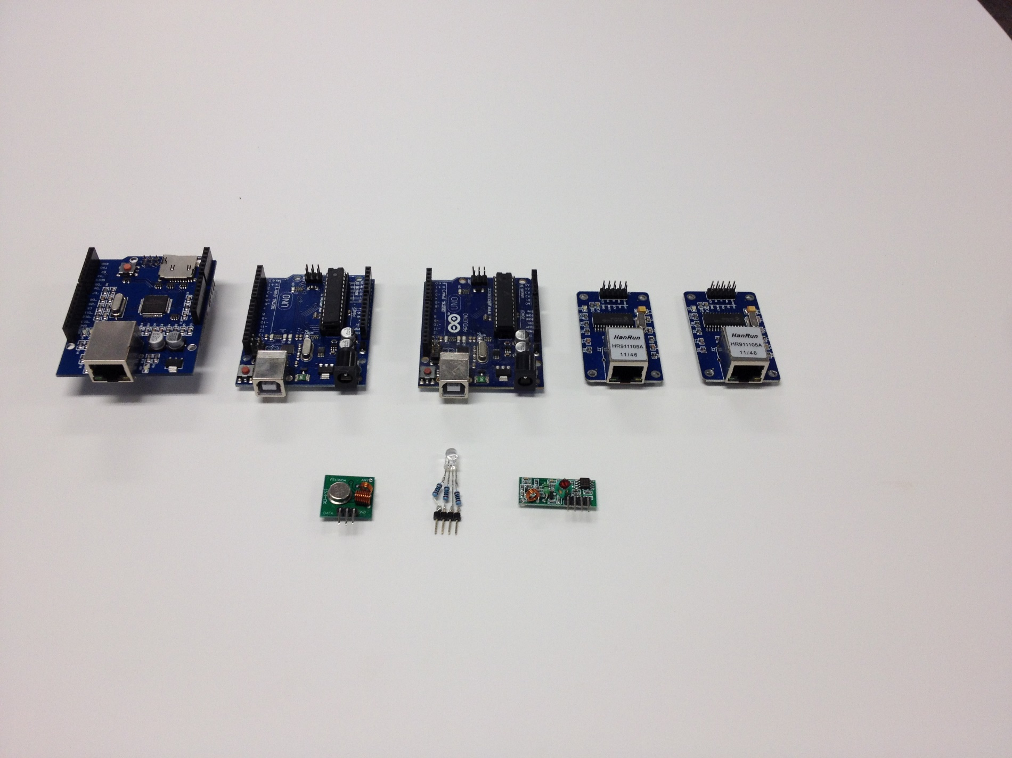

#### Accuracy Test

##### Aim

To test how accurately a data packet could be sent to the device using HTTP.

##### Equipment

* Computer
* RPi
* W5100
* Ethernet Hookup
* Arduino (needed for testing W5100 and Ethernet Hookup)
* Router
* Program on device that rebounds the message
* Program on computer that reads incoming messages

##### Procedure

1. A data packet is sent to the device from my computer (each data packet is filled with just “1”’s)
2. The device then rebounds the data packet as it received it back to the sender
3. A program on my computer then reads the rebounded data packet and saves it in a text file
4. I repeat this 1000 times (automated)
5. I then opened the text file in a text editor (Sublime Text 3) and used a function which shows what characters are used and how many times
6. For every character that is not a “1”, means that the device inaccurately received (or sent) a data packet

##### Safety

Safety should always be used when communicating on the internet, and especially when allowing devices to access parts of your network. I took caution here and used a router that was not connected to the internet, but instead just my own local area network.

##### Discussion

This test is not very professional, but I could not think of a better way to do it. Some flaws arise, such as the errors that could occur when the device sends data packets back. The errors here do not need to be noted as these devices are never sending information anyway. A better way to do this test would be to buy proper equipment which is used to measure the accuracy of such devices.

##### Conclusion

To conclude, the test results are not as I expected. Each device scored a perfect 100%, meaning that I do not need to worry about the accuracy of data.

#### Latency Test

##### Aim

To test the reaction time of the device after being on standby for one hour. This is important to test as when the user uses the system, they would want to test real time feedback to their actions.

##### Equipment

* Computer
* RPi
* W5100
* Ethernet Hookup
* Arduino (needed for testing W5100 and Ethernet Hookup)
* Router
* Program on device that rebounds the message
* Program on computer that sends a data packet and records the time it takes for the packet to be received back

##### Procedure

1. A data packet is sent to the device from my computer
2. My computer starts recording the time (automated through the program)
3. The device then rebounds the data packet as it received it back to the sender
4. A program on my computer then reads the rebounded data packet
5. The program stops the counter and records the time to a text file
6. This is repeated every hour for 24 hours

##### Discussion

I think this is a well thought out test. It is unfortunate that it takes 24 hours to test each device though, and I am sure there is a fast way to test all 3 in 72 hours. To speed up the time, I could have tested all 3 devices at once. I did not do this though as I did not want to overcomplicate the test and bring in more unknowns.

##### Conclusion

To conclude, these tests results are very helpful and truly shows the difference in each product. The Ethernet Hookup performed the worst with an average of 2.34s reaction time, with a range of 1.2s – 5.6s, this is not good enough for my product. The W5100 performed second best with some very good results, averaging 0.51s with a range of 0.45s – 0.55s, this is a very pleasing result and will not exclude the W5100 from the product. The RPi blitzed the other two though with an average reaction time of 0.11s, with a range of 0.10s – 0.14s. So in conclusion, the Ethernet Hookup will not be good enough for this product and will be excluded using these results.

|  |  |  |  |
| --- | --- | --- | --- |
|  | Ethernet Hookup  20140814_123132 | Wiznet5100  C:\Users\Lachlan\AppData\Local\Microsoft\Windows\INetCache\Content.Word\20140814_123137.jpg | Raspberry Pi (RPi)  C:\Users\Lachlan\AppData\Local\Microsoft\Windows\INetCache\Content.Word\20140814_123708.jpg |
| Price | 4 | 10 | 45 |
| Accuracy | 100 | 100 | 100 |
| Latency | 2.34s | 0.51s | 0.11s |
| Ease of Use | Hard | Hard | Easy |
| Approximate Life Span | 5 years | 5 years | 15 years (but estimated to be more) |
| Hardware Used | SPI | SPI | Self-Contained |
| Power Consumption | Low | Low | High |

Using the results it is evident that I should use the RPi in my project, as it not only beats the other two devices in Ethernet functionality, but it also allows for high speed processing on its micro-processor.

### How I made the PCBs

I am making my own circuit boards for the project, so I need to know how to make them, and practice doing this. PCB is a component made out of layers of insulating materials with electrical conductors. The insulator can be made of many materials, mainly plastic, fibreglass and ceramics. During manufacture, the extra conductors that are not required, are etched off leaving a printed circuit where I can attach my electronic components.

Safety

* I am going to be using very corrosive chemicals and eye protection must be worn.
* If any acid gets on my skin/clothes rinse under water immediately.
* If any acid ends up in my eyes rinse under water immediately and seek medical help.
* A blow torch can get very hot and should not be handled by a student, so my teacher offered to do it for me.

What materials/equipment are needed?

* Copper Clad Board
* Waterproof Permanent Marker
* Etching Acid (Ferric Chloride or Ammonia Persulphate)
* Drill
* Tinsnips
* Hacksaw
* Steel Wool
* Bath for etching
* Multimeter
* Blow Torch

Procedure:

I started with a rough design of what I wanted the PCB to look like. Note, this PCB was a test and does not reflect the final PCB.

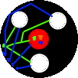

I then used an Airline marker pen to careful draw the schematic on a piece of copper PCB.

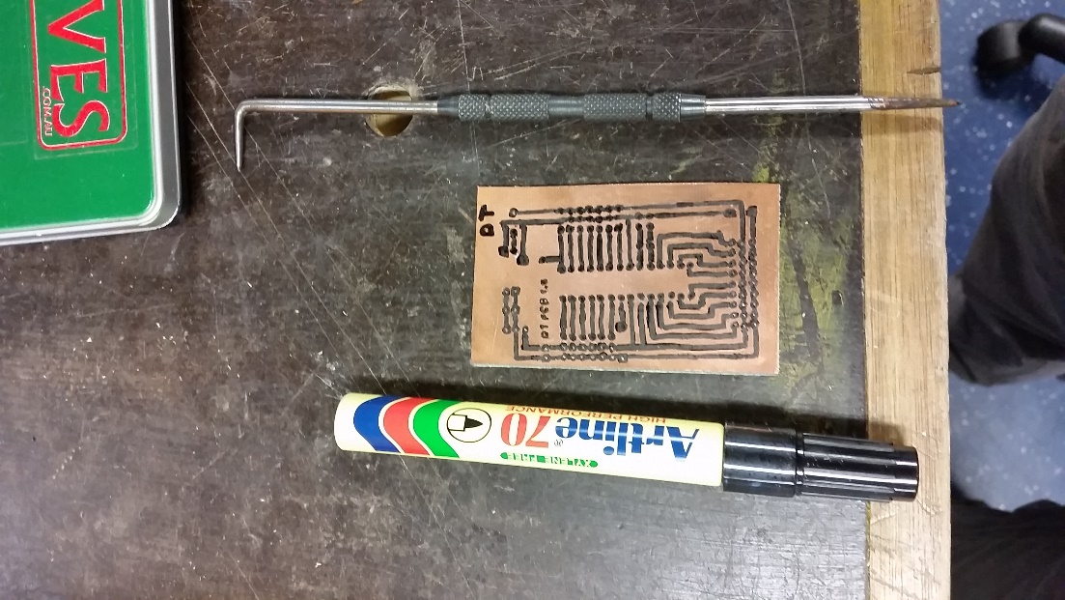

I let the ink dry and made a solution of hot Ferric Chloride (acid) to dissolve the copper, but leaving the marker pen where it was, and protecting the copper underneath it.

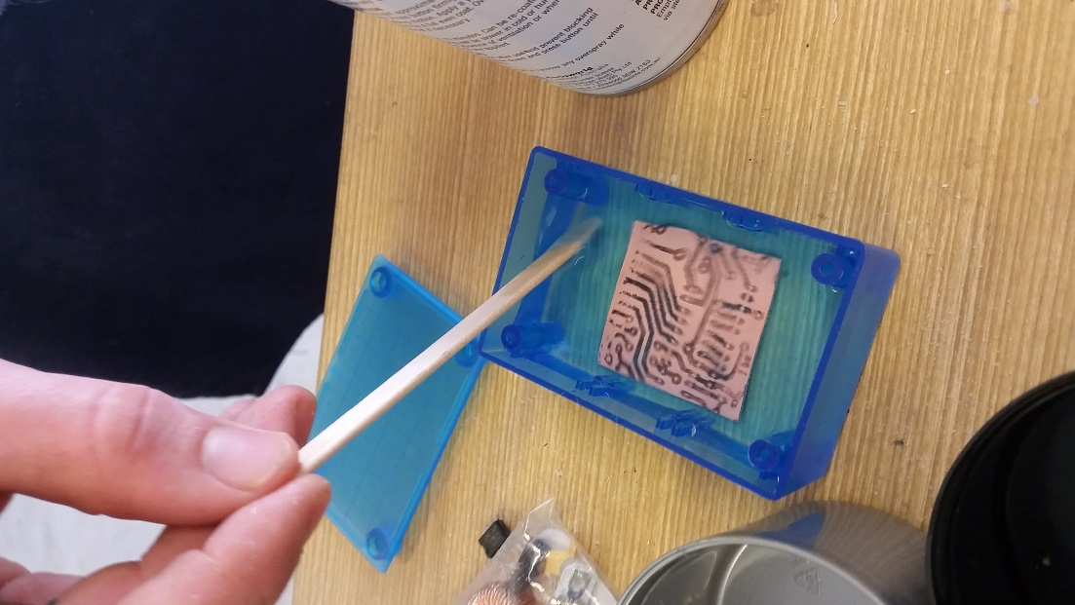

After 15 minutes, the copper had fully dissolved where it was exposed to the acidic solution. What remained was a piece of clear PCB with market on it. I used steel wool to scratch the marker off, leaving the copper where it was.



I drilled out where I had marked the white and red circles, this will be where I put the components. The final product looked like this:

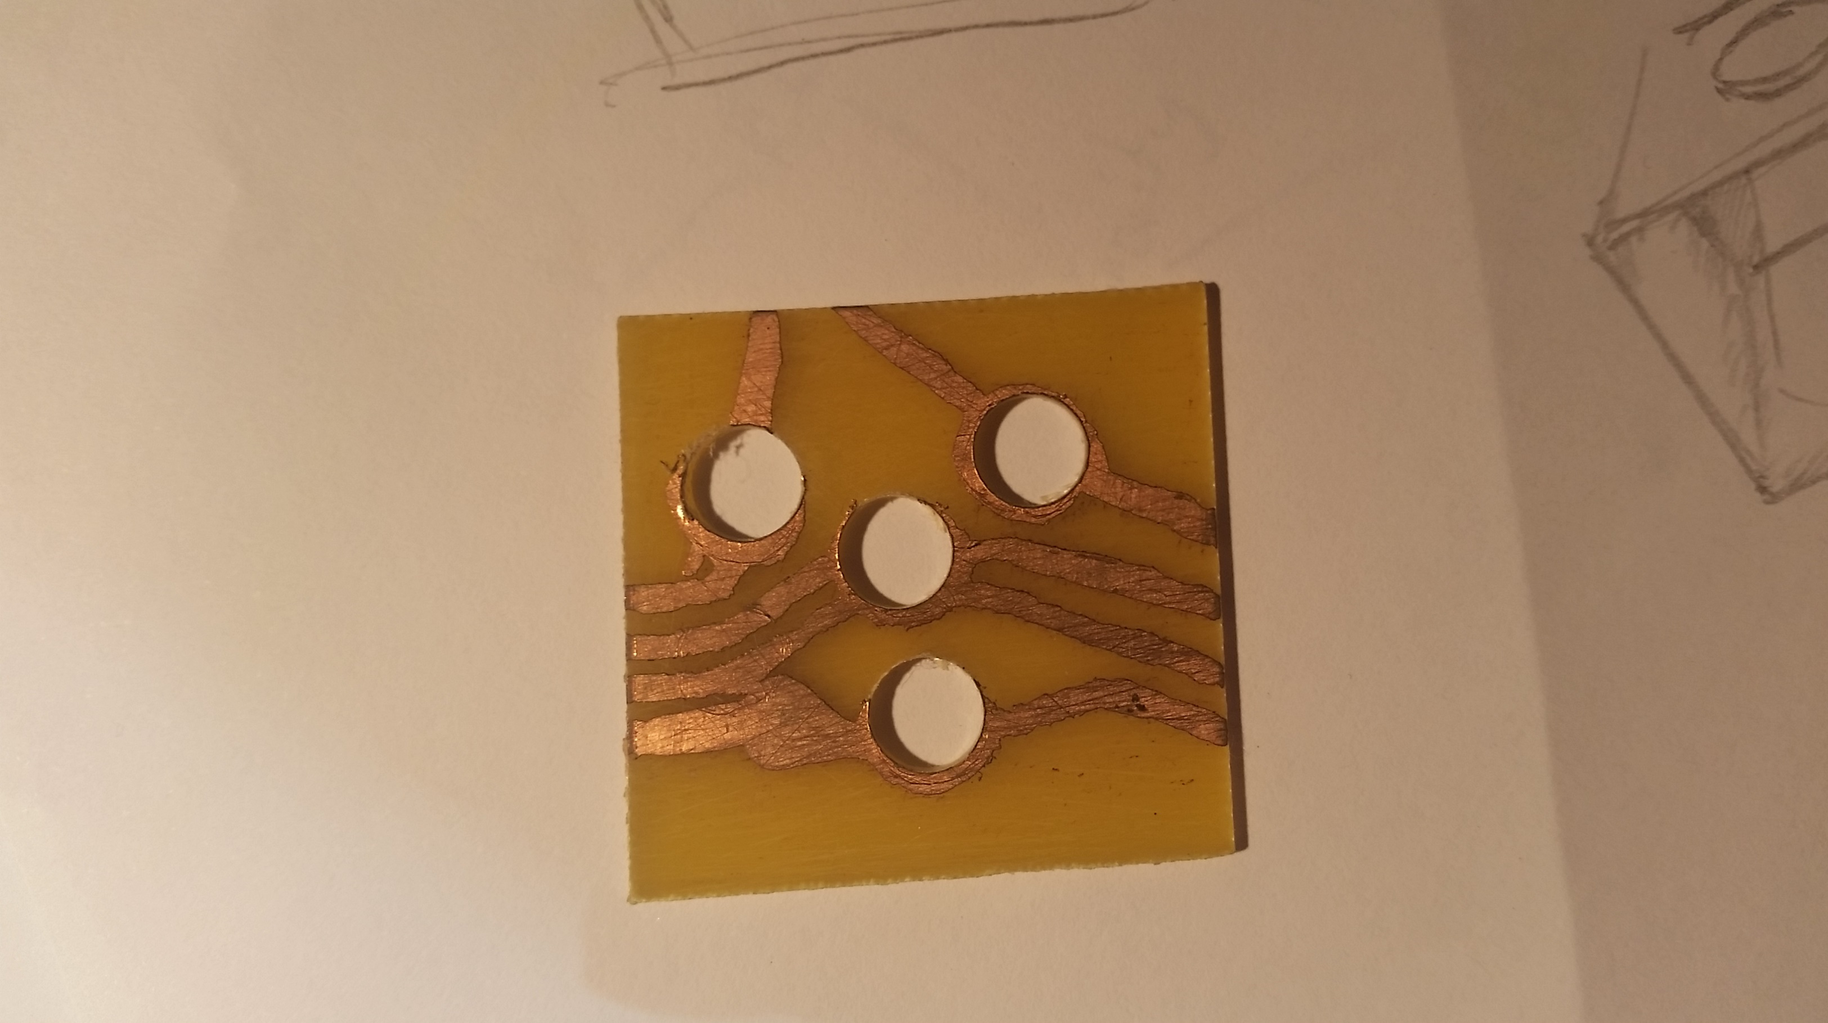

The PCB turned out to be a success in some aspects, but a complete failure in others. Through this testing of the PCB method, we discovered that we would need a much more accurate way of drawing our schematic onto the plain PCB. My school teacher came up with a good idea, and that was to print the schematic out using an ink printer, compress the printout to a piece of copper PCB and heat using fire until the ink melted onto the PCB.

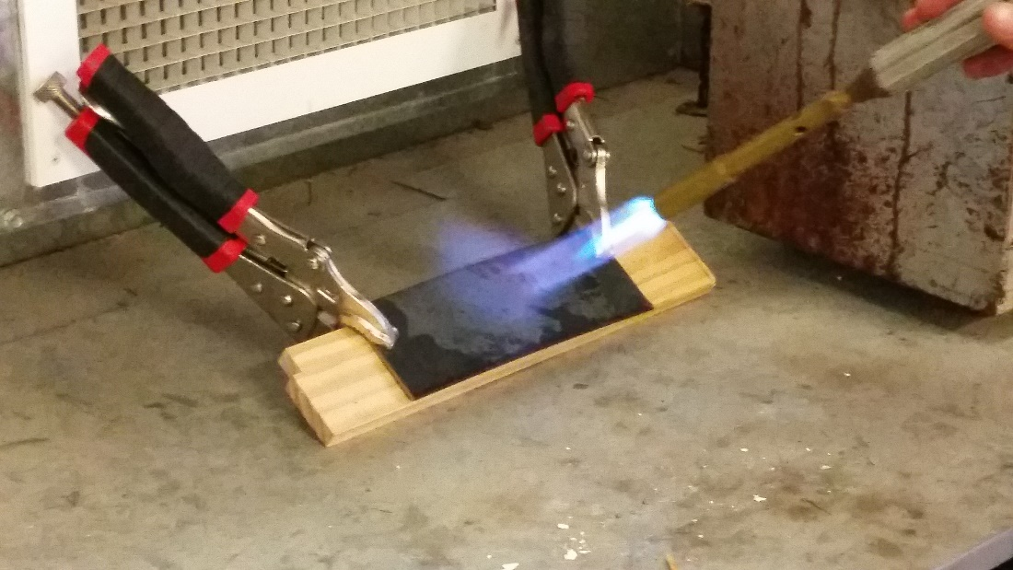

After removing the PCB (and paper) from the compressed contraption, we were left with a PCB board that looked like a complete failure.

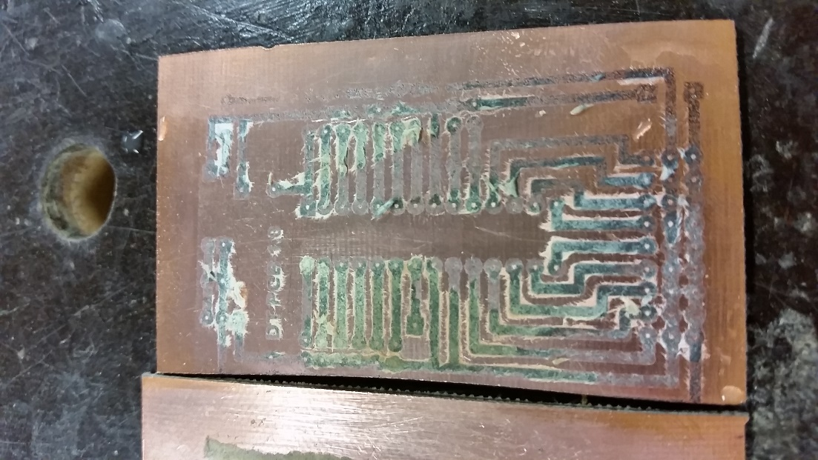

We decided to make three more, just to test that we had not failed making the PCB, and they all turned out similar. We were quite annoyed, but decided to put them in acid anyway to dissolve. After about 10 minutes in the acid, we discovered that we may have actually done the procedure correctly.

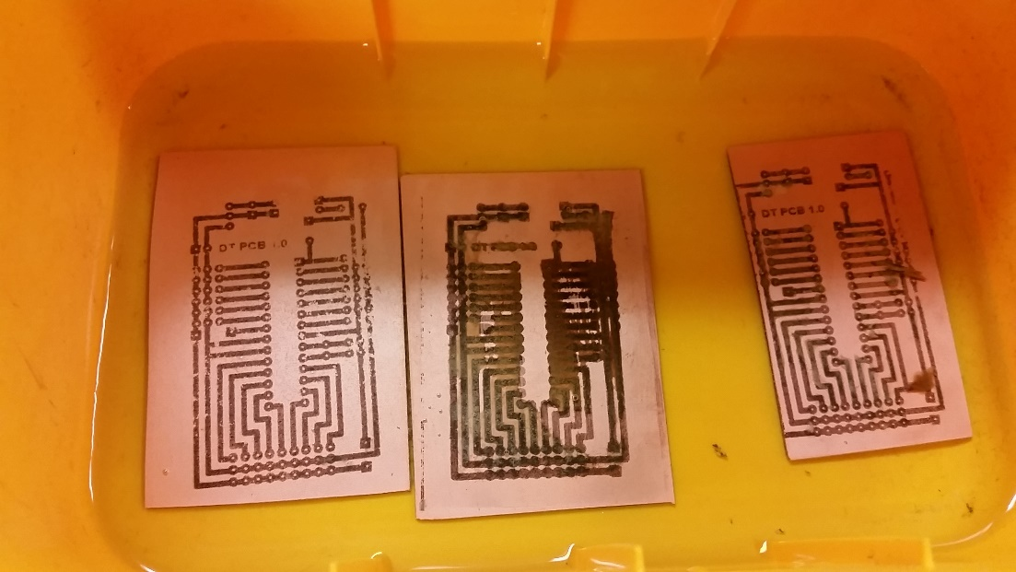

With the board on the left looking pretty much perfect. After 10 more minutes the exposed copper finally dissolved and left us with three completely different looking PCBs

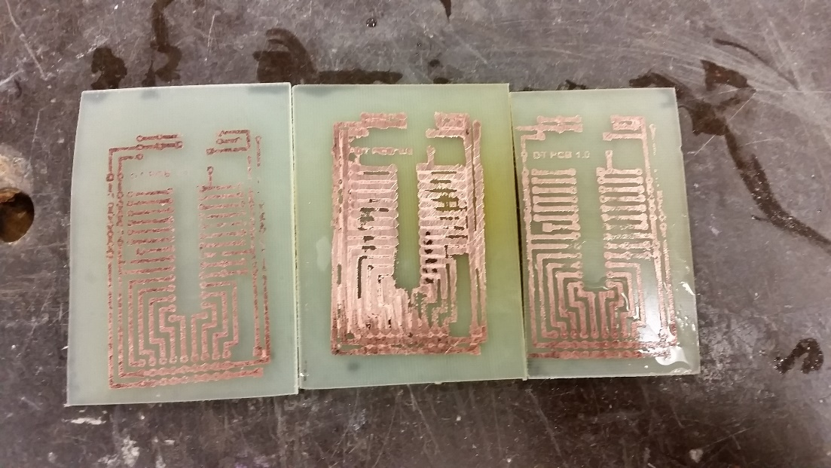

The left one turned out the best, but had a few issues in the top right hand corner due to what I expect to be heating issues. The one in middle must have gotten heated too much and resulted in a failure of a PCB where all the different lines were connected. The one on far right was perfect though, and we decided to use it to continue testing my circuit. Here is a close-up of the far left PCB:

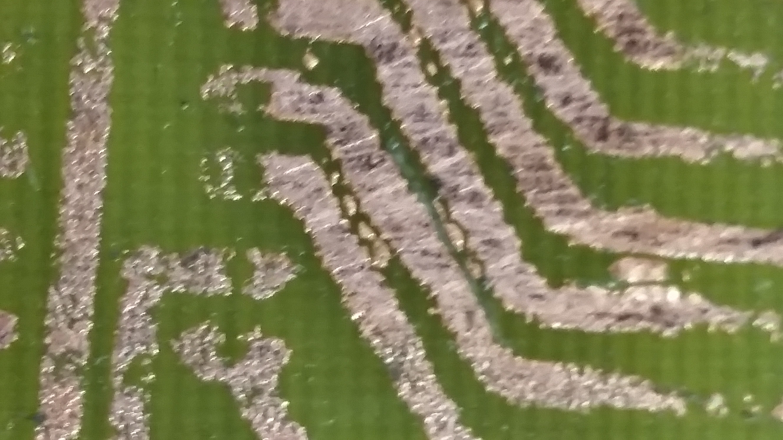

To conclude, in the end this product was a failure, and I removed it from my design. I instead replaced the PCBs with perf-boards, which are better for prototyping and rapid development.

## Product Display

To properly display my product, I decided to build a display for it.

|  |  |
| --- | --- |
| Aspect | Why is this aspect needed? |
| Enclosed | The display will need to be enclosed as to allow it to be dark. I want it dark so the light looks more bright and colourful. |
| White | The display needs to be white so that each colour can appear as it is without being changed. For instance, if the display was blue, the red light would look purple. |
| Mimics a room | I want this display to feel like it is a room, this will allow the person who is looking at it to properly grasp how it would look like in a proper sized room. |
| Large in volume | I want the room to be large in volume so the colours and brightness are spread out evenly and not just concentrated on the one spot. The light would be concentrated on one spot if a surface was 10cm or closer to the LEDs. |
| Clear top | I need the top to be clear to properly demonstrate the circuitry that is driving these lights. |
| Lightweight | I want this display to be lightweight so it can be easily carried around, especially from my house to school and back. |
| Clean | The room must look clean. If the room does not look clean it will reflect poorly on my product, making it seem as if I did not care about it. |

I started off by drawing a 3D view and a cut section view of the box. This helped me to understand what I might expect.

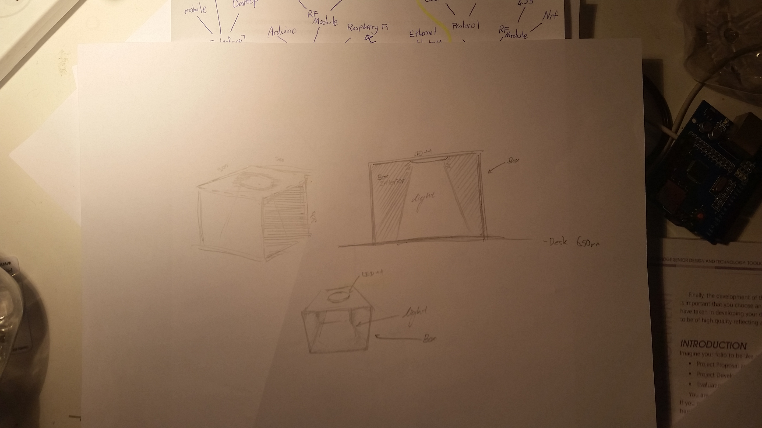

Next I asked my Design and Technology teacher to help me design what this box should technically look like from the isometric view, side view, and top view.

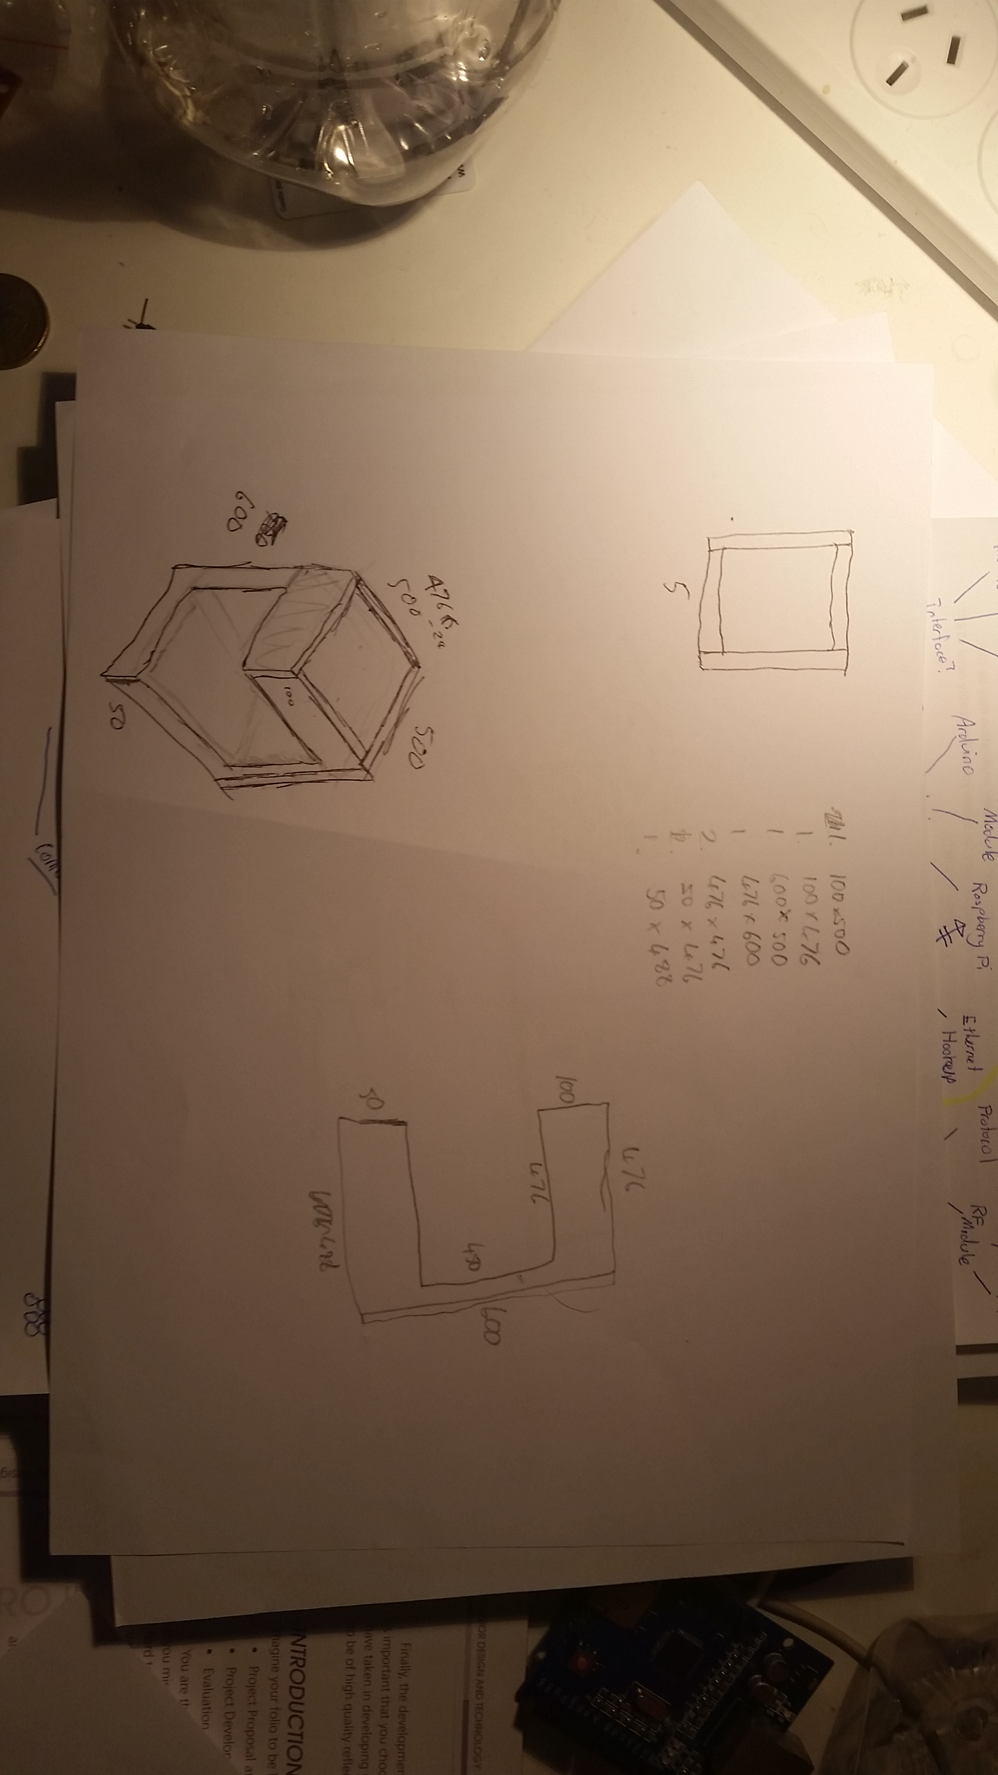

After I was happy with how it looked, I planned out the size I wanted the box to be. I chose a very large size as to meet my previous criteria. After, I planned out the shapes and sizes of the pieces of wood I needed to use in the product. There was a few pieces, so we decided to use the bandsaw to cut the wood. Safety and caution were a priority so my Design and Technology teacher cut the wood for me, while we both wore ear and eye protection. The wood was chosen based on its weight and smoothness, this links back to my criteria in the lightweight and clean aspects. We decided to go for MDF wood as it perfectly matched this criteria. After cutting the wood, I assembled the pieces using PVA glue. Unfortunately on evaluation I realised that there were a view cracks in the joins of the wood, and some bits were not level. I fixed this problem by using putty to patch up the holes, then sanding it away. In the end I ended up with a completed box.

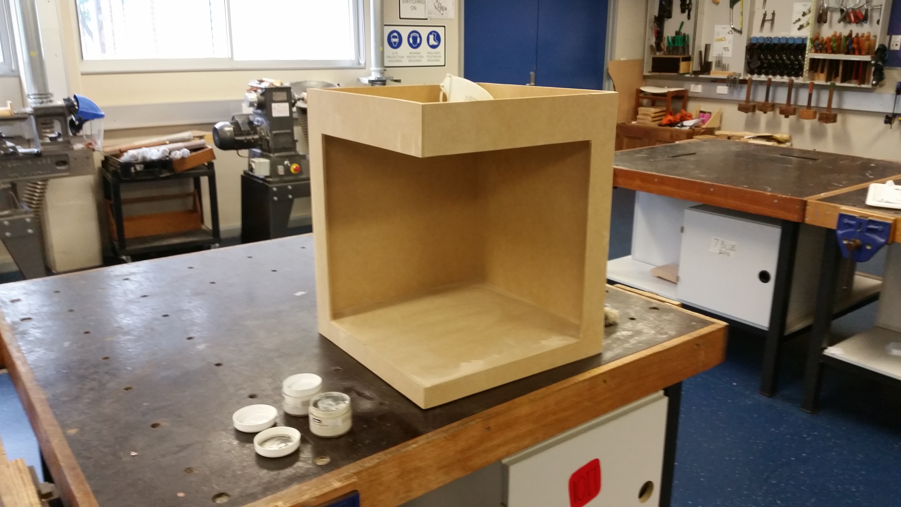

To make this completed box into my completed display, I needed to paint it white. The school had some white paint I could use. I painted each side twice for a nice clean final product.

# Project evaluation

## Ongoing Evaluation

### Record of Progress – Diary

Throughout the project I have kept a record of what I have been doing and how I have followed my action plan to keep on track. I have also made evaluations throughout the project recording decisions made and reasons for doing so. These should be evident when looking through the folio.

|  |  |
| --- | --- |
| How project developed to completion | Comments and Evaluation |
| 2013, Term 4 |  |
| * Looked into what project to do for my MDP through mind mapping of the current needs of the market and finding potential niches | Term 4 I did not complete as much of my project as I should have. I wanted to take this time to ensure I am making something that I would like to continually design for the next 3 terms. |
| 2014, Term 1 Week 1 |  |
| * I continued my research to explore the gaps in the market and stumbled upon my grandmothers need for a visual alert system | This was very handy to develop a solution to a need of someone who I can talk to everyday. |
| Week 2 |  |
| * I began my research of existing products and whether it was possible to fulfil my grandmother’s need. | This was not too difficult as some bits were obvious and did not need in-depth research. Research was still required though. |
| Week 3 |  |
| * After finding out that I could in fact make this product, I also discovered that I could include many more features and decided to interview people from the target market | Again, developing a solution for my grandmother made it easy to interview people from the target market. |
| Week 4 |  |
| * I was sick this week and did not complete much work | Unfortunately I am prone to becoming sick, and this held me back some weeks |
| Week 5 |  |
| * I attempted to make up for last week by doing lots of MDP work. I researched which resources to use for my project and completed a long evaluation of all previous task completed | This allowed me to get my mind back on DT after a week off |
| Week 6 |  |
| * Sick |  |
| Week 7 |  |
| * Sick |  |
| Week 8 |  |
| * Sick |  |
| Week 9 |  |
| * I was now a little behind in what I wanted to complete by this stage, so I decided that I would build a prototype to attempt to see just how this product would turn out. | At this stage I was panicking about my DT work as I had just missed 3 weeks of MDP work and 2 weeks of in class DT lessons. |
| Week 10 |  |
| * I was still completing the prototype. On Friday it was 70% complete, but I am not planning on working on it on the weekends. | The prototype was coming along well at this stage. I was surprised when a few functions worked that I expected not to. |
| * After the holidays I had a positive outlook on this prototype and decided to put more effort into it. By this stage it was 80% done, but the scope of it was far greater than my vision for it in week 10 of term 1. | Evaluated what I wanted this prototype to do, and decided to make it much more. |
| Week 2 |  |
| * I was still working on my prototype. I decided to contact a professional who gave me sound advice on interfacing the mobile phone to the system. | Contacting the professional was a good idea, and concluded with me getting some valuable tips. |
| Week 3 |  |
| * Finished my first prototype. Really liked how it turned out. Also finished evaluation of the prototype as evaluation was done thought out building it due to time issues. Started to plan out second prototype | I may have been going too fast at this stage trying to cover lost time. I maybe should of taken my time, even though I was behind in the Time Plan |
| Week 4 |  |
| * Still building second prototype |  |
| Week 5 |  |
| * Continue building my prototype but began to explore some different methods of how I could go about this prototype | This exploration really allowed me to experiment and explore different solutions to the same problem. |
| Week 6 |  |
| * I finished my second prototype. I was happy how this one turned out, and was happy with the new methods I had explored. |  |
| Week 7 |  |
| * I was sick this week and did not do much work for my MDP. I did buy parts for the product though so they would be ready for the next week or when I would feel better. | Maybe I should have persisted through the sickness of this week as it was starting to get a bit late in terms of time. |
| Week 8 |  |
| * I began to crack down at the third and final prototype by programming all the logic behind it and drawing up the schematics |  |
| Week 9 |  |
| * Continued doing exactly what I was doing last week |  |
| Week 10 |  |
| * Programming was finishing up, and schematic drawing was complete so I decided to start building the final circuit needed | This proved more difficult than I expected, but I still managed to finish the schematics in the allocated amount of time, but not in the right time frame, I was about 3 days behind. |
| Term 3 Week 1 |  |
| * The circuits were almost all complete except for the circuit for the LEDs |  |
| Week 2 |  |
| * Completed all programming and all circuits, and decided it was time to put everything together. | I actually finished this before I had planned, which allowed me to focus on my folio. |
| Week 3 |  |
| * I finally finished this week, with a fully functional product and fully documented folio. | I felt very relieved this week |
| Week 4 |  |
| * Just fixed up little bits of my Folio. This week was mainly a rest. I also had other exams I had to. | I found a few mistakes in my folio and was thankful I had the time to fix these. |

## Analysis and Evaluation of Aesthetic and Functional Aspects of my Design

This design project is primarily used for its function and so these features are most important, however aesthetics is also considered.

|  |  |
| --- | --- |
| Functional Aspects | |
| Is it a quality product? | It is a quality product as it follows my criteria to success. It also follows all safety guidelines. |
| Is it safe? | Yes it is safe. The product follows all the safety guidelines and the voltage never exceeds 5V. |
| Does it work as expected and intended? | Yes it works as expected. I have thoroughly tested it through numerous scenarios and for the bugs I have found, I have removed them. |
| Is it long lasting? | Yes it is long lasting. The lowest minimum expected lifetime is 10 years, which is the RF module I used. |
| Is it made from appropriate materials | Yes it is made from appropriate materials that I have individually tested. |
| Has the target market been considered? | Yes, the target market was in mind throughout the entire design process. I have also had ongoing evaluation that has linked the product back to the needs and it has always fulfilled it. |
| Is it easy to use? Are there any instructions needed for appropriate and safe use? | Yes it is easy to use. The product use is intuitive and was readily understood and operated by my grandmother and two of her friends. |
| Aesthetic Aspects | |
| Is it an attractive design? | As I was concentrating on functionality, I believe the look and appeal of the product could be improved. However, this would involve additional costs and time which I did not have. |
| Is it likely to appeal to the target market? | Yes, it will appeal to its target market due to its functionality, not its aesthetics |
| How could I improve the look of this design? | I could possibly reduce the overall size so that it is less obtrusive but because it would increase the cost of the product, I would have to go back to the target market to see if they would want to pay the extra cost for something they do not see. |

## Final Evaluation with Respect to the Individual, Society, and the Environment

|  |  |
| --- | --- |
|  | Key Impact and Rationale |
| Individual  (Hearing impaired, elderly) | * Improved safety (visual smoke alarms reduce risks of missing fire hazards) * Greater confidence to remain independent (because visual alerts compensate for hearing impairment) * More comfortable life style (from automating switching) * Financial savings (from reducing electricity costs because of automated system and use of power saving components) |
| Society | * Benefits from more confident elderly hearing impaired individuals (potential reduction in age care and welfare costs funded by the government) |
| Environment | * Pollution reduction (Reducing electricity usage directly impacts the amount of greenhouse gasses produced) * Low environmental impact (the materials in my product and the cost to build are minimal and the long life span of my product means environmental production impacts are spread over at least 10 years. |

## Relationship of the Final Product to the Project Proposal

### Prototypes (Evaluation of Success)

|  | Prototype 1 | Prototype 2 | Prototype 3 | Prototype 3.5 (final Light++) |
| --- | --- | --- | --- | --- |
| Description | Prototype 1 consisted of the basic features of the product. It uses an Arduino to control 3 LEDs. The light was not bright enough nor was easy to control with this prototype. | Prototype 2 consisted of more features than Prototype 1. It used an Arduino to control the lights which were much more luminous then the previous prototype. More features were added such as a doorbell mode. | Prototype 3 was all most a perfect success. It consisted of an Arduino that could control the LED circuit and had most features built into it | This prototype evolved from Prototype 3 through the creation of its own microprocessor circuit. It also fixes a lot of bugs that were in Prototype 3. |
| Build a system that delivers a visual alert in place of an audible alert | Yes, proven through product testing | Yes, proven through product testing | Yes, proven through product testing | Yes, proven through product testing |
| Keep costs less than $1000 for final product | Yes, final costs are approximately $100 for the computer system, and $25 per light. This is under $1000 for an average home with 20-30 lights | Yes, final costs are approximately $100 for the computer system, and $25 per light. This is under $1000 for an average home with 20-30 lights | Yes, final costs are approximately $100 for the computer system, and $25 per light. This is under $1000 for an average home with 20-30 lights | Yes, final costs are approximately $100 for the computer system, and $25 per light. This is under $1000 for an average home with 20-30 lights |
| Design especially for the elderly demographic | No | No | Yes, proven by field tests by members of the target market | Yes, proven by field tests by members of the target market |
| Keep research and development costs less than $350 | Yes proven by my finance plan | Yes proven by my finance plan | Yes proven by my finance plan | Yes proven by my finance plan |
| Reduce the struggle to turn off lights due to aches and pains | No | Yes, proven by product testing | Yes, proven by product testing | Yes, proven by product testing |
| Reduce high costing electricity bills each month | Yes, proven by product testing | Yes, proven by product testing | Yes, proven by product testing | Yes, proven by product testing |
| Allow the light brightness to be customised by the user | No | No | Yes, proven by product testing | Yes, proven by product testing |

Based on the evaluation above, I am confident that it demonstrates that the final product meets the requirements of the design brief, and therefore can be considered a success.